

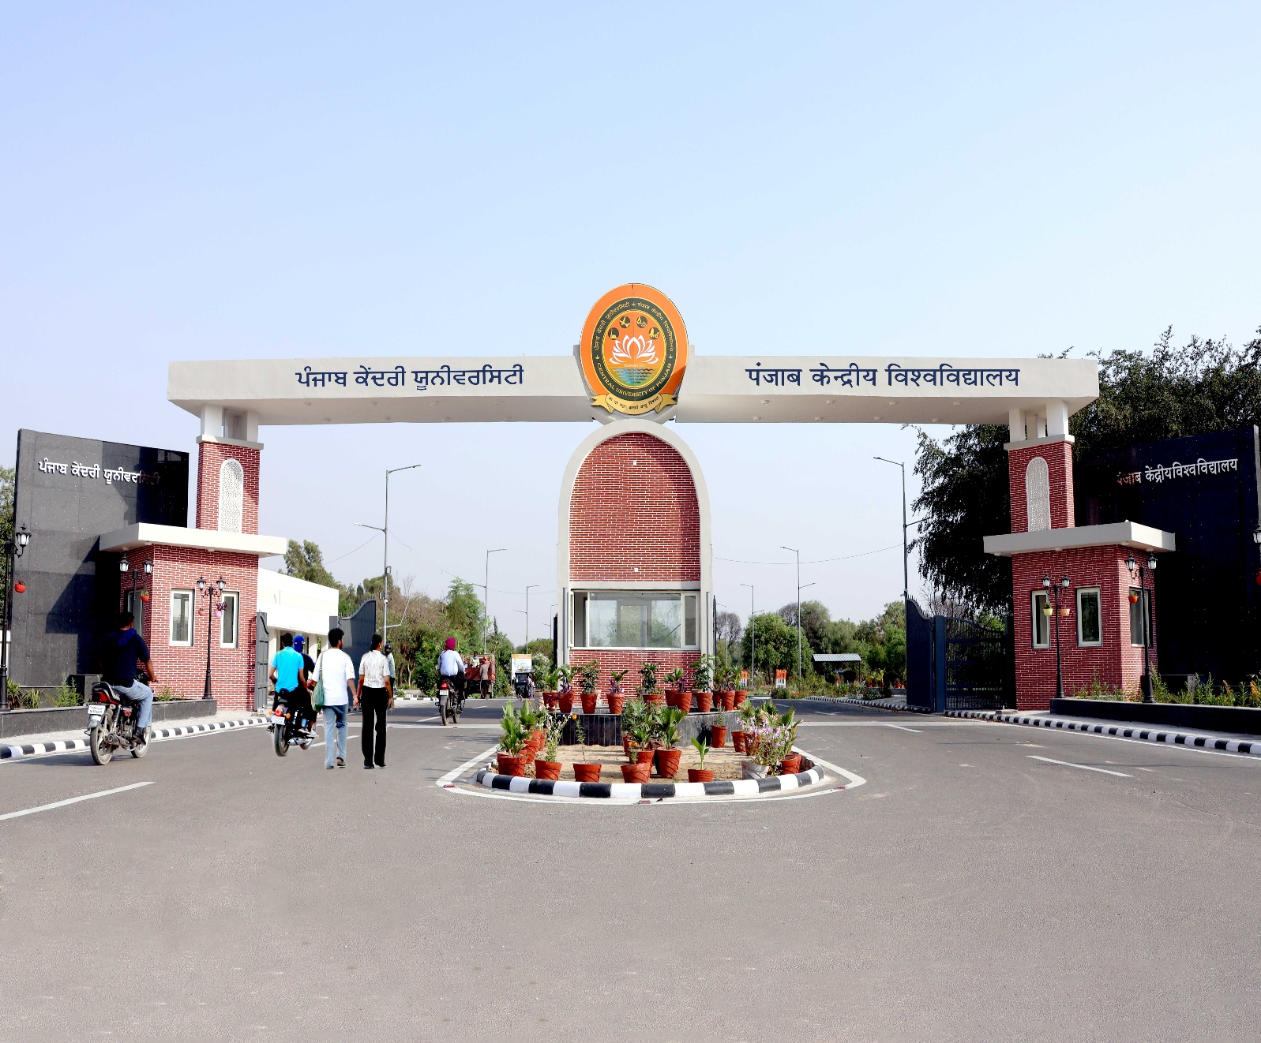
NAAC ACCREDITED ‘A+’ GRADE UNIVERSITY & 77th RANK IN NIRF-2025

PROSPECTUS

Admissions to

Post Graduate Programmes

Academic Session : 2026-27

FROM THE VICE-CHANCELLOR’S DESK
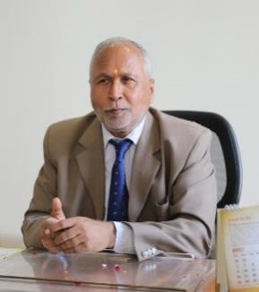
Prof. Raghavendra Prasad Tiwari
Dear Students,

Welcome to the Central University of Punjab!

The Central University of Punjab has been established through an Act of Parliament: "The Central Universities Act, 2009" by Govt. of India. The territorial jurisdiction of Central University of Punjab is whole of the State of Punjab.

The University has an energy-efficient green campus with state-of-the-art infrastructure coupled with modern research and sports facilities in an area of over 500 acres at village Ghudda, District Bathinda, Punjab.

The Central University of Punjab has been ranked in the top 100 for the last seven consecutive years in 2019, 2020, 2021, 2022, 2023, 2024 and 2025 by NIRF (University catagory). At a young age of 16 years of establishment, the University has proved itself with NAAC 'A+' Grade.

The University is one of the fast growing Higher Educational Institutions in the Country and committed to Sustainable Development Goals.

The University envisions to transform the minds to serve the humanity through skill and innovation driven teaching and research; values and community outreach. The University offers a wide range of instructional and research facilities across integrated and cross-disciplinary studies, to create an ignited workforce responsive to regional, national and global needs in tune with the requirements of academics, industry, business and administration and to address the issues and concerns of the community.

We aim to constantly motivate young minds to experience the excitement and adventure that education offers and inculcate amongst students and faculty, the healthy habits of self-reliance rather than dependence. We strive on holistic development of personality to face challenges of life while ensuring welfare of all life forms and life support systems; activate creative instincts, motivate independent thinking; develop questioning minds and to nurture a sense of integrity, ethics, uncompromising honesty, democratic values, respect for human rights and deep concern for the disadvantaged section of the society.

We, at Central University of Punjab understand that success is based on high quality courses, good facilities, friendly ambience and dedicated academic staff. Here, we practise what we teach and our students can count on full support of faculty and administration.

Our strength lies in dedicated and meritorious faculty, quality infrastructural research facilities and visibility in research output. The innovative courses so designed also save precious time, money and energy of the students while they remain focused to the field of their choice.

With a much-focussed approach, the university is undoubtedly poised to write a new chapter on the academic horizon of India.

I appreciate you considering the Central University of Punjab as your next academic institution and look forward to welcome you!

With best wishes,
(Raghavendra Prasad Tiwari)

 | About Central University of Punjab
The Central University of Punjab was established in 2009 by an Act of Parliament. The University ranked 77th by the National Institutional Ranking Framework (NIRF), 2025. In the prestigious Times Higher Education (THE) World University Rankings 2026 university is in the 601–800 rank band. Further, in the second accreditation cycle, the University has been accredited with "A+" grade by the National Assessment and Accreditation Council (NAAC). The university is ISO (9001:2015) certified for quality management system in educational services and ISO 14001:2015 certified for Environment Management System. The University has a mission of providing wide range of instructional and research facilities across integrated and cross-disciplines, to promote innovation in teaching, learning and research, and cross-pollinate new ideas, new technologies and new world-views. It aims to create an ignited workforce responsive to regional, national and global needs in tune with the requirements of academia, industry and business. |  |  |  |  |  | 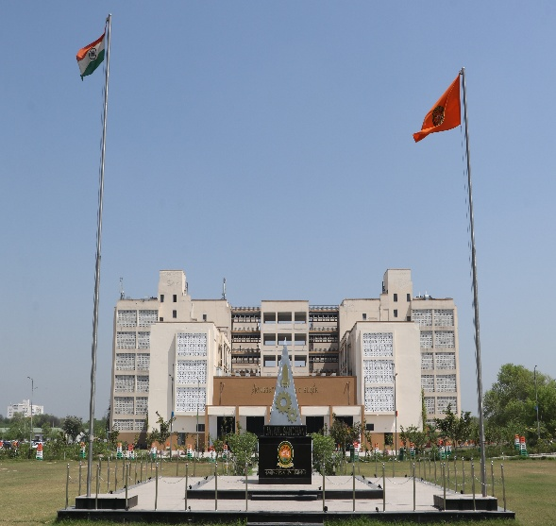
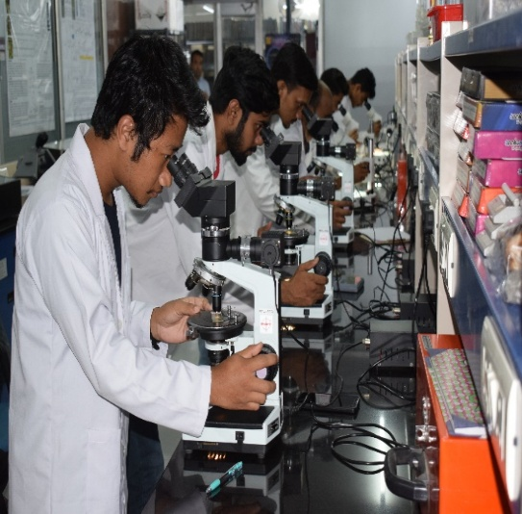 |  | The University started in a Camp Office provided by the State administration in March, 2009. Presently, the University is functioning from its 500-acre campus situated at village Ghudda in Bathinda District of Punjab. The University has attained 122 h-index (Scopus), 125025 citations (Scopus) and 4561 Papers (Scopus). The University is Anchor Institution for online courseware development for Environment Sciences for e-PG Pathshala platforms. The University has also developed MOOCs for SWAYAM. The University has a state-of-the-art Central Instrumentation Laboratory, Computer Centre and the University Library to provide high-end facilities to its faculty and students. Air-conditioned lecture rooms, well-equipped science laboratories, a 125-seater seminar hall and a 250-seater air-conditioned auditorium (under construction) support the academic activities.
The 500 acres University campus is designed to be environment friendly and energy efficient and is conforming to GRIHA-IV norms. The University Master Plan has provisionally been certified with 5-star rating by GRIHA and TERI. The University secured first position in 14th National Youth Parliament (in group level) competition. Two teachers of the University had been part of “36th Indian Scientific Expedition to Antarctica” and worked at Bharti & Maitri research stations. Nine Departments of the University have been supported with DST-FIST grants. University has secured DST-PURSE grant and has an incubation centre under iTBI NIDHI scheme of DST. |  |  |  | 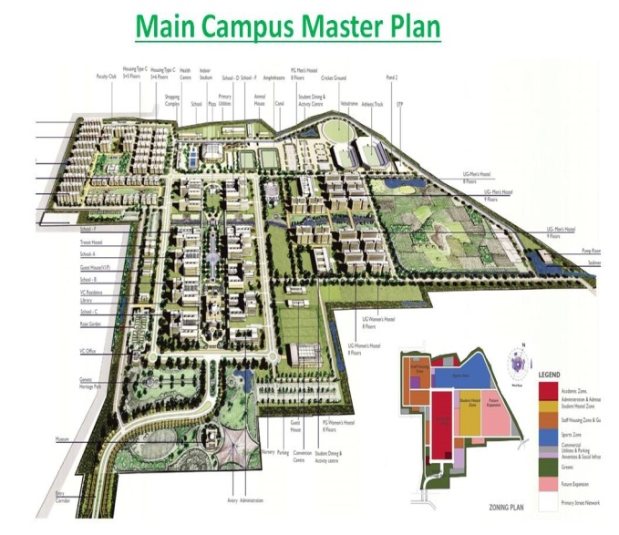
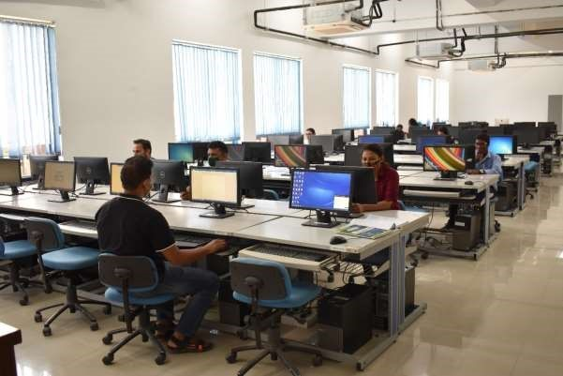 |  |  | Currently, the University has 31 Departments under 11 Schools of Studies in the areas ranging from Sciences, Technology, Humanities, Law and Social Sciences. The University has implemented the National Education Policy, 2020 from the session 2021-22. The University offers Bachelor, Masters and Ph.D. Programmes. It also offers Short-Term Courses for skill development. It is a validation of University's growing credibility among the students that during the year 2025-26, a total of 289587 applications were received for 1264 seats for the admission to Master’s Programmes through CUET, with a demand ratio of 1:230. For UG Programmes, 3429 applications were received for 350 seats. For Ph.D. Programmes, 992 applications were received for 217 seats.
Besides celebrating international and national commemorative days, students are encouraged to organize and participate in annual sports and cultural events throughout the year. To cater to the financial needs of the students, the University provides scholarships and interest-free loans out of the Students Welfare Fund and has also implemented Earn-While-You-Learn Scheme. |  |  |  |  | 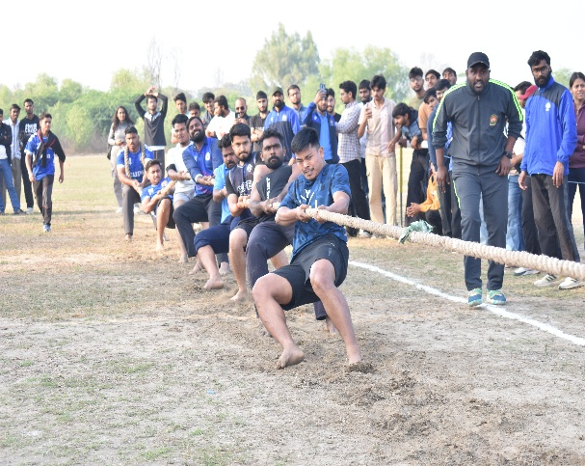
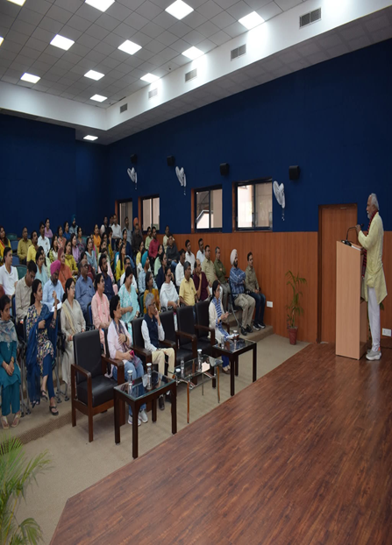 |  | The University is multi-cultural and multi-lingual as it has students from 28 States, 07 UTs and International students from Afghanistan, Bangladesh, Burundi, Egypt, Ethiopia, Ghana, Indonesia, Iran, Kenya, Lesotho, South Africa, Swaziland, Syria, Tanzania, Uganda, Yemen, faculty members and non-teaching staff from most of the States. The University takes pride in its exceptionally qualified and committed faculty as all are NET qualified and have doctoral degree. It is remarkable that majority of the faculty have the experience of working in international laboratories and prestigious foreign Universities. The university faculty includes DST INSPIRE, Ramanujan Fellow, Ramalingaswami Fellow, UGC-FRP and DAAD fellow etc. Faculties are also members of prestigious Royal Society of Chemistry, Linnean Society of London and INYAS-INSA. The University has a good Research Projects: Faculty Ratio. So far, over 229 Extramural Research Grants from external agencies and 160 research Seed Money grants (University funded) have been sanctioned to the faculty.  With a focused approach, the University is undoubtedly poised to write a new chapter on the academic horizon of India.

VISION

- The University envisions to continuously transform the minds to serve humanity through skills, innovation and sustainability driven teaching and research; values and community outreach.

MISSION

- Provide a wide range of instructional and research ecosystem for inter-, multi- and trans-disciplinary approaches to impart holistic learning,

- Promote skills and innovation in teaching-learning and research, and crosspollinate new ideas, technologies and new world-views,

- Create an ignited and inclusive workforce responsive to regional, national and global needs in tune with the requirements of academia, industry and society,

- Envisage to respond dynamically and creatively towards shifting paradigms in education to meet the changing needs of the evolving society.

ACADEMIC PROGRAMMES AND ELIGIBILITY

The Central University of Punjab is offering following Post Graduate Programmes during the Session 2026-27:

02 years Master’s Degree Programmes for Session 2026-27 (4 Semesters)

The two-year Postgraduate programme will have three options: 1. All four semesters of coursework, 2. Three semesters of coursework and one semester of research, and 3. Two semesters of coursework and two semesters of research. Different academic departments may offer one or more of the above three options. If more than one option is offered, students shall choose the option by the end of first (or) second semester, as per the curriculum of the concerned department. A minimum of six students are required in each option except in the PG program where the total number of students is less than six. However, PG programmes regulated by AICTE, NCTE, PCI etc. shall be as per their guidelines.

- A student is eligible for a PG programme in a discipline corresponding to either major or minor(s) discipline in UG programme.

- Irrespective of the major or minor disciplines chosen by a student in a UG programme, a student is eligible for admission in any discipline of PG programmes if the student qualifies CUET in the discipline of the PG programme. However, PG programmes regulated by AICTE, NCTE, PCI etc. shall be as per their guidelines.

S.No. | Programme |  | Eligibility |  |  | No. of seats#
SCHOOL OF BASIC SCIENCES
DEPARTMENT OF APPLIED AGRICULTURE
1. | M.Sc. Food Science and Technology |  | Bachelor’s degree in Basic Science / Agriculture Science or Applied Subjects including Food Processing Technology, Food Science and Technology, Food and Nutrition, Food Technology, Dairy Technology, Biotechnology, Agricultural Process Engineering, Chemical/Biochemical Engineering, Veterinary Sciences, Horticulture, Fisheries, etc. streams with 50% marks {45% in case of SC/ST/OBC(NCL)/PWD} from a recognized Indian or foreign University. |  |  | 30
2. | MBA (Agribusiness) |  | Bachelor’s degree in Agriculture Sciences or in Agriculture related / Humanities, Social Sciences, Pure Sciences, Engineering, Commerce, Management, Design & Planning and Rural Management/ Development, etc., disciplines, and related disciplines with at least 50% marks or equivalent CGPA {45% in case of SC/ST/OBC(NCL)/PWD} from a recognized Indian or foreign University.  Agriculture related disciplines include: Agriculture, Agri Business Management, Commercial Agriculture, Agricultural Marketing and Cooperation, Agricultural Engineering, Biochemistry, Biotechnology, Dairy Technology, Fisheries, Food Technology, Food Processing Engineering, Forestry, Horticulture, Sericulture, Home-Science, Veterinary Science & Animal Husbandry and all other streams of Agriculture and Applied subjects. |  |  | 30
DEPARTMENT OF BIOCHEMISTRY
3. | M.Sc. Biochemistry |  | Bachelor’s degree in Life Sciences or related field with 50% marks {45% in case of SC/ ST/ OBC (NCL)/ PWD} from a recognized Indian or foreign University. |  |  | 35
DEPARTMENT OF BIOTECHNOLOGY AND BIOINFORMATICS
4. | M.Sc. Bioinformatics |  | Bachelor’s (B.Sc./ B.Tech) degree in Biological Sciences (Life Sciences/ Biotechnology/ Pharmaceutical Sciences/ Veterinary Sciences/ Agricultural Sciences/ Medical Sciences)/ Mathematical Sciences/ CSE/ Physical Sciences/ Chemical Sciences with 50% marks {45% in case of SC/ ST/ OBC (NCL)/ PWD} from a recognized Indian or foreign University. |  |  | 20
5. | M.Sc. Biotechnology |  | Bachelor’s degree in any branch of Life Sciences with 50% marks {45% in case of SC/ ST/ OBC (NCL)/ PWD} from a recognized Indian or foreign University. |  |  | 30
DEPARTMENT OF BOTANY
6. | M.Sc. Botany |  | Bachelor’s degree in Life Sciences or related field with 50% marks {45% in case of SC/ ST/ OBC (NCL)/ PWD} from a recognized Indian or foreign University. |  |  | 35
DEPARTMENT OF CHEMISTRY
7. | M.Sc. Chemistry |  | Bachelor's degree in any branch of Sciences with 50% marks {45% in case of SC/ ST/ OBC (NCL)/ PWD} and Chemistry as one of the subject from a recognized Indian or foreign University. |  |  | 35
8. | M.Sc. Chemistry (Specialization in Applied Chemistry) |  | Bachelor's degree in any branch of Sciences with 50% marks {45% in case of SC/ ST/ OBC (NCL)/ PWD} and Chemistry as one of the subject from a recognized Indian or foreign University. |  |  | 25
DEPARTMENT OF COMPUTATIONAL SCIENCES
9. | M.Sc. Chemistry (Theoretical and Computational Chemistry) |  | Bachelor’s degree in Science with Chemistry as a subject with 50% marks {45% in case of SC/ ST/ OBC (NCL)/ PWD} in aggregate from a recognized Indian or foreign University. |  |  | 15
10. | M.Sc. Physics (Computational Physics) |  | Bachelor’s degree in Science with Physics and Mathematics as main subjects with 50% marks {45% in case of SC/ ST/ OBC (NCL)/ PWD} in aggregate from recognized Indian or foreign University. |  |  | 20
DEPARTMENT OF MATHEMATICS AND STATISTICS
11. | M.Sc. Mathematics |  | Bachelor’s degree with Mathematics as main subject with 50% marks {45% in case of SC/ ST/ OBC (NCL)/ PWD} in aggregate from a recognized Indian or foreign University. |  |  | 40
12. | M.Sc. Statistics |  | Bachelor’s degree (B.A/ B.Sc.) with Mathematics/ Statistics as a main subject with 50% marks {45% in case of SC/ ST/ OBC (NCL)/ PWD} in aggregate from a recognized Indian or foreign University. |  |  | 25
DEPARTMENT OF MICROBIOLOGY
13. | M.Sc. Microbiology |  | Bachelor’s degree in Life Sciences or related field with 50% marks {45% in case of SC/ ST/ OBC (NCL)/ PWD} from a recognized Indian or foreign University. |  |  | 35
DEPARTMENT OF PHYSICS
14. | M.Sc. Physics |  | Bachelor’s degree in Science with 50% marks {45% in case of SC/ ST/ OBC (NCL)/ PWD} in aggregate in Physics and Mathematics as main subject from recognized Indian or foreign University. |  |  | 45
DEPARTMENT OF ZOOLOGY
15. | M.Sc. Zoology |  | Bachelor’s degree in any branch of Life Sciences with 50% marks {45% in case of SC/ ST/ OBC (NCL)/ PWD} from a recognized Indian or foreign University. |  |  | 35
SCHOOL OF EDUCATION
DEPARTMENT OF EDUCATION
16. | M.A. Education |  | Bachelor’s degree with 50% marks {45% in case of SC/ ST/ OBC (NCL)/ PWD} from a recognized Indian or foreign University. |  |  | 15
17. | M.Ed. |  | B.Ed. degree with 50% marks {45% in case of SC/ ST/ OBC (NCL)/ PWD} from a recognized Indian or foreign University. |  |  | 30**
DEPARTMENT OF PHYSICAL EDUCATION
18. | M.P.Ed. |  | (a) Bachelor of Physical Education (B.P.Ed) or equivalent with at least 50% marks.  OR  Bachelor of Science (B.Sc.) in Health and Physical Education with at least 50% marks.  (b) The reservation in seats and relaxation in the qualifying marks for SC/ ST/ OBC/ PWD and other categories shall be as per the rule of the Central Government/ State Government, whichever is applicable. |  |  | 40
SCHOOL OF ENGINEERING AND TECHNOLOGY
DEPARTMENT OF COMPUTER SCIENCE AND TECHNOLOGY
19. | M.Tech. Computer Science & Technology |  | B.Tech./ B.E. in Computer Science and Engineering/ Information Technology/ Electronics/ Electronics & Communication or an equivalent degree in an appropriate area/branch from a recognized Indian or foreign University/ Graduates (AMIETE/ AMIE) from Institution of Electronics and Telecommunication Engineers (IETE) in Computer Science & Engineering or M.Sc. (Computer Science/ Information Technology) or an equivalent degree in an appropriate area from a recognized Indian or foreign University or MCA from a recognized Indian or foreign university or equivalent and with minimum 55% marks or 6.0 CGPA {50% Marks or 5.5 CGPA for SC/ ST/ OBC (NCL)/ PWD} Preference will be given to candidates having valid GATE score. |  |  | 30*
20. | M.Tech. Computer Science & Engineering (Cyber Security) |  |  |  |  | 24*
SCHOOL OF ENVIRONMENT AND EARTH SCIENCES
DEPARTMENT OF ENVIRONMENTAL SCIENCE AND TECHNOLOGY
21. | M.Sc. Environmental Science and Technology |  | Bachelor's degree in any branch of Science/technology with minimum 50% marks {45% in case of SC/ ST/ OBC (NCL)/ PWD} from a recognized Indian or foreign University. |  |  | 35
DEPARTMENT OF GEOGRAPHY
22. | M.A./M.Sc. Geography |  | M.A. Geography: Bachelor's degree in arts with Geography as main subject with 50% marks {45% in case of SC/ ST/ OBC (NCL)/ PWD} in aggregate from recognized Indian or foreign University. |  |  | 40
22. |  |  | M.Sc. Geography: Bachelor's degree in Science with Geography as main subject with 50% marks {45% in case of SC/ ST/ OBC (NCL)/ PWD} in aggregate from recognized Indian or foreign University. |  |  | 40
DEPARTMENT OF GEOLOGY
23. | M.Sc. Geology |  | Hons. in Geology at B.Sc. Level/ Bachelor's degree with Geology as main subject with 50% marks {45% in case of SC/ ST/ OBC (NCL)/ PWD} in the aggregate in Science subjects from a recognized Indian or foreign University. |  |  | 35
SCHOOL OF HEALTH SCIENCES
DEPARTMENT OF COMMUNITY MEDICINE AND HEALTH
24. |  | M.Sc. Community Medicine and Health |  | Bachelor’s degree in any branch of Life Sciences with 50% marks {45% in case of SC/ ST/ OBC (NCL)/ PWD} from a recognized Indian or foreign University. | 30
DEPARTMENT OF HUMAN GENETICS AND MOLECULAR MEDICINE
25. | M.Sc.  Human Genetics |  | Bachelor’s degree in any branch of Life Sciences/ M.B.B.S. or B.D.S. with 50% marks {45% in case of SC/ ST/ OBC (NCL)/ PWD} from a recognized Indian or foreign University. |  |  | 30
26. | M.Sc.  Molecular Medicine |  | Bachelor's degree in any branch of Animal/ Medical Sciences/Life Sciences with 50% marks {45% in case of SC/ ST/ OBC (NCL)/ PWD} from a recognized Indian or foreign University. |  |  | 30
DEPARTMENT OF PHARMACEUTICAL SCIENCES AND NATURAL PRODUCTS
27. | M. Pharm. Pharmaceutical Chemistry |  | Bachelor’s degree in Pharmacy with 55% marks {50% in case of SC/ ST/ OBC (NCL)/ PWD} marks from a recognized Indian or foreign University and preference will be given to candidates having valid GPAT score. |  |  | 15
28. | M. Pharm. Pharmacognosy |  | Bachelor’s degree in Pharmacy with 55% marks {50% in case of SC/ ST/ OBC (NCL)/ PWD} from a recognized Indian or foreign University and preference will be given to candidates having valid GPAT score. |  |  | 15
29. | M.Sc. Chemical Sciences (Medicinal Chemistry) |  | Bachelor’s degree in Science with Chemistry as a subject with 50% marks {45% in case of SC/ ST/ OBC (NCL)/ PWD} in aggregate from a recognized Indian or foreign University. |  |  | 25
DEPARTMENT OF PHARMACOLOGY
30. | M. Pharm. (Pharmacology) |  | Bachelor’s degree in Pharmacy with 55% marks {50% in case of SC/ ST/ OBC (NCL)/ PWD} from a recognized Indian or foreign University and preference will be given to candidates having valid GPAT score. |  |  | 15
SCHOOL OF INFORMATION & COMMUNICATION STUDIES
DEPARTMENT OF MASS COMMUNICATION & MEDIA STUDIES
31. | M.A. Journalism & Mass Communication |  | Bachelor’s degree in any discipline with a minimum of 50% marks {45% in case of SC/ ST/ OBC (NCL)/ PWD} from a recognized Indian or foreign University. |  |  | 35
DEPARTMENT OF LIBRARY AND INFORMATION SCIENCE
32. | M. Lib. I. Sc. (Master of Library & Information Sciences |  | Bachelor’s degree with 50% marks {45% in case of SC/ ST/ OBC (NCL)/ PWD} from a recognized Indian or foreign University. |  |  | 20
SCHOOL OF INTERNATIONAL STUDIES
DEPARTMENT OF PUBLIC POLICY AND GOVERNANCE
33. |  | M.A. Public Policy and Governance |  | Bachelor's degree in any discipline with at least 50% marks {45% in case of SC/ ST/ OBC (NCL)/ PWD} in aggregate from a recognized Indian or foreign University. | 30
DEPARTMENT OF SOUTH AND CENTRAL ASIAN STUDIES
34. | M.A. Political Science |  | Bachelor's degree with Political Science with 50% marks {45% in case of SC/ ST/ OBC (NCL) /PWD} in aggregate or Bachelor’s degree in any other discipline with 55% marks {50% in case of SC/ ST/ OBC (NCL)/ PWD} in aggregate from a recognized Indian or foreign University. |  |  | 40
35. | M.A. Politics and International Relations |  | Any Bachelor's degree with 50% marks {45% in case of SC/ ST/ OBC (NCL)/ PWD} in aggregate from a recognized Indian or foreign University. |  |  | 25
SCHOOL OF LANGUAGE, LITERATURE AND CULTURE
DEPARTMENT OF ENGLISH
36. | M.A. English |  | Bachelor’s degree with at least 50% marks {45% in case of SC/ ST/ OBC (NCL)/ PWD} in aggregate with at least 50% marks {45% in case of SC/ ST/ OBC (NCL)/ PWD} in English as optional subject, or 50% marks {45% in case of SC/ ST/ OBC (NCL)/ PWD} in English as compulsory subject from a recognized Indian or foreign University. |  |  | 40
DEPARTMENT OF HINDI
37. | M.A. Hindi |  | Bachelor’s degree with 50% marks {45% in case of SC/ ST/ OBC (NCL)/ PWD} in aggregate and having studied Hindi as a subject from a recognized Indian or foreign University. |  |  | 20
DEPARTMENT OF PUNJABI
38. | M.A. Punjabi |  | Bachelor’s degree with 50% marks {45% in case of SC/ ST/ OBC (NCL)/ PWD} in aggregate from a recognized Indian or foreign University. |  |  | 15
DEPARTMENT OF PERFORMING AND FINE ARTS
39. | Master of Arts (M.A.)-Music (Vocal) |  | Bachelor Degree with 50% marks (45% in case of SC/ ST/ OBC (NCL)/ PWD) from a recognized Indian or foreign university such as Bachelor Degree with any subject Music/Gurmat Sangeet or BPA/ B.Mus.  OR  Bachelor Degree in any discipline with 50% marks (45% in case of SC/ ST/ OBC (NCL)/ PWD) from a recognized Indian or foreign university with any Diploma/ Prabhakar/ Visharad/ Sangeet Shiromani/ any PG diploma in music.  Note: Selection will be done on the basis of aptitude test of 100 marks with 60% weightage to practical and 40% weightage to viva voce examination of the candidates shortlisted on the basis of entrance examination. |  |  | 10
40. | Master of Performing Arts (MPA)- Theatre |  | Bachelor’s degree in any discipline with 50% marks {45% in case of SC/ ST/ OBC (NCL)/ PWD} from a recognized Indian or foreign University.  Note: Selection will be done on the basis of Aptitude test of 100 marks with 60% weightage to Practical and 40% weightage to viva-voce examination of the candidates shortlisted on the basis of entrance examination. |  |  | 15
SCHOOL OF LEGAL STUDIES
DEPARTMENT OF LAW
41. | L.L.M. |  | Bachelor’s degree in Law with 50% marks {45% in case of SC/ ST/ OBC (NCL)/ PWD} from a recognized Indian or foreign University. |  |  | 50
SCHOOL OF MANAGEMENT
DEPARTMENT OF FINANCIAL ADMINISTRATION
42. | M.Com. |  | Bachelor’s degree in Commerce with minimum of 50% marks or equivalent grade {45% in case of SC/ ST/ OBC (NCL)/ PWD} in aggregate from a recognized Indian or foreign University. |  |  | 35
DEPARTMENT OF HOSPITALITY AND MANAGEMENT
43. | MBA Hospitality and Tourism Management |  | Bachelor's degree in any discipline with at least 50% marks {45% in case of SC/ ST/ OBC (NCL)/ PWD} in aggregate from a recognized Indian or foreign University. |  |  | 30
SCHOOL OF SOCIAL SCIENCES
DEPARTMENT OF ECONOMIC STUDIES
44. | M.A. Economics |  | Bachelor’s degree with 50% marks {45% in case of SC/ ST/ OBC (NCL)/ PWD} from a recognized Indian or foreign University and who had studied Economics/ Statistics/ Management. |  |  | 35
DEPARTMENT OF SOCIOLOGY
45. | M.A. Sociology |  | Bachelor's degree in any discipline with at least 50% marks {45% in case of SC/ ST/ OBC (NCL)/ PWD} in aggregate from a recognized Indian or foreign University. |  |  | 35
DEPARTMENT OF HISTORY
46. | M.A. History |  | Bachelor’s degree with History with 50% marks {45% in case of SC/ ST/ OBC (NCL)/ PWD} in aggregate or Bachelor's degree in any other discipline with 50% marks {45% in case of SC/ ST/ OBC (NCL)/ PWD} in aggregate from a recognized Indian or foreign University. |  |  | 35
DEPARTMENT OF PSYCHOLOGY
47. | M.A. Psychology |  | Bachelor’s degree in any discipline with 50% marks {45% in case of SC/ ST/ OBC (NCL)/ PWD} from a recognized Indian or foreign University. |  |  | 40
SRI GURU TEGH BAHADUR CENTRE OF STUDIES IN INDIC CIVILIZATION AND RELIGIOUS TRADITIONS
48. | M.A. Bharatiya Civilization Studies |  | Bachelor's degree in any discipline with at least 50% marks {45% in case of SC/ ST/ OBC (NCL)/ PWD} in aggregate from a recognized Indian or foreign University. |  |  | 30
 |  |  | Total seats |  |  | 1404

*In Department of Computer Science & Technology, 50% Seats will be filled through CCMT- 2026. Further, any seats remaining vacant after CCMT-2026 couselling shall be filled through CUET scores by the Department.

**Department may fill upto 60 seats as approved by NCTE.

Paid seats shall be limited to a maximum of ten seats on supernumerary basis except programmes approved by regulatory bodies such as AICTE, NCTE, PCI guidelines.

#Admission shall be given to the wards of the University employees in PG programmes under 5% quota as supernumerary seats. If the number of seats corresponding to 5% quota is less than one, a minimum of one seat shall be reserved. The quota in the programmes approved by regulatory bodies such as AICTE, NCTE, PCI, may be given as per their guidelines.

It is mandatory for students in every PG program to complete at least one course on SWAYAM platform accompanied by credit transfer. The students shall be responsible for payment of fees for courses on SWAYAM. Students are encouraged to take skill-based courses on SWAYAMPLUS platform.

Note:
- The University reserves the right not to offer the programme in any particular discipline due to administrative reasons or if the response to the programme is not adequate. The decision of the University will be final in this regard.
- The University reserves the right to change the number of seats in any programme. It will be accordingly notified on the University website.
- Reservation/relaxation will be given as per Government of India/ University Rules as adopted by the University time to time.
- This prospectus is subject to alteration (s) & modification (s) and the same will be notified on University website.
- This prospectus is for information only and it does not constitute a legal document.
- For detail please visit University website www.cup.edu.in

Admission Criteria to Master’s Degree Programme for Session 2026-27

- Admission to all Master’s Degree Programmes shall be based on the merit of the students in Common University Entrance Test (CUET) -2026.
- The candidates are advised to remain in touch with the website(s) CUET- 2026 www.nta.ac.in, https://exams.nta.ac.in/CUET-PG/ for updated information.
- Candidate must ensure that, they should have all the original documents of their respective qualifying examinations at the time of verification of Documents/Registration.
- For the admission in Master Programme, candidate must fulfill the eligibility criteria on the date of verification of Documents/Registration.
- Ensuring the eligibility for applying to a particular Programme will be the sole responsibility of the candidate.

HOW TO APPLY FOR CUET- 2026
Candidates can apply online only. For online application, visit the home page of CUET-2026 website(s) www.nta.ac.in, https://exams.nta.ac.in/CUET-PG/ for necessary instructions.

Instructions for submitting Online Application:
- Please read eligibility criteria and other requirements before submitting the application form.
- To apply for admission to a Programme, eligible candidates must complete the online Application Form and submit it.

Important Instructions:

- The University reserves the right not to offer the Programme in any particular discipline if the response to the Programme is not adequate. The decision of the University will be final in this regard.

- Ensuring the eligibility for applying to a particular programme will be the sole responsibility of the candidate. If at any stage, it is found that students do not fulfill the eligibility criteria for admission, his/her admission will be cancelled immediately and no refund of fees will be issued and action will be taken as per rules.

IMPORTANT DATES AND TEST CENTRES FOR CUET- 2026
Please visit the National Testing Agency (NTA) website(s): https://cuet.nta.ac.in/, www.nta.ac.in for important dates and Test Centres for CUET-2026.

Pattern and Syllabus of Entrance Test
Please visit the National Testing Agency (NTA) website(s): https://cuet.nta.ac.in/, www.nta.ac.in for details of pattern and syllabus of the entrance test for all the Programmes.

Entrance Test Fee and Mode of Payment
Please visit the National Testing Agency (NTA) website(s): https://cuet.nta.ac.in/, www.nta.ac.in for details of entrance test fees and mode of payment.

ONLINE COUNSELLING FOR CENTRAL UNIVERSITY OF PUNJAB

- Before applying for Counselling for Admission in Central University of Punjab, candidate must ensure that they have appeared in CUET- 2026.
- Admission to all Programmes offered by the Central University of Punjab is purely on the Merit of CUET-2026 score of a student.
- Candidate is required to fill Application Form separately to participate in the counselling of Central University of Punjab.
- The candidate who do not apply online for counselling of Central University of Punjab, shall not be considered for admission. Application for admission/ counselling shall be accepted only in online mode.
- Please read eligibility criteria and other requirements before submitting the application form.
- The detailed schedule and modalities of online counseling including application forms shall be notified on the University website after the declaration of Common University Entrance Test (CUET) result.

SCHEDULE OF REGISTRATION AND ORIENTATION

Schedule of Registration and Orientation will be notified later on, after declaration of CUET results

NOTE: The candidates are required to deposit the prescribed fee on or before the date to be announced at the time of admission.

IMPORTANT NOTE: The last date of Admission/Counselling will be notified later. However, if seats remain vacant or vacancy of seats occurs after withdrawals of admission, the vacant seats shall be filled from the waiting list.
The cut-off date for admission including shifting/operating of waiting list, if any, shall be notified later. There after no admission shall be made by the University.

RESERVATION POLICY
The reservation is as per UGC/Government of India guidelines as adopted by the University from time to time.

MEDICAL EXAMINATION
The student admitted in the University shall have to submit a medical fitness certificate from Govt. Hospital or University Health Centre that he/she is medical fit to pursue higher education.

MEDIUM OF INSTRUCTION
Medium of instruction for all the Programmes is English/Hindi except the language Programmes for which the medium of instruction is the language concerned.
Meduim of Examination/Disseration: English except the language Programmes for which the medium of instruction is the language concerned.

PROGRAMME SYLLABI
Syllabi of PG programmes is available on university website.

It is mandatory for students in every PG programme to complete at least one course on SWAYAM platform followed by credit transfer. The students shall be responsible for payment of fees.

Students are encouraged to take skill-based courses on SWAYAMPLUS platform.

REFUND POLICY FOR ACADEMIC FEE
With reference to the UGC guidelines, in the event of a student / candidate withdrawing before the starting of the Programme, the waitlisted candidates should be given admission against the vacant seat. The entire fee (Academic) collected from the student shall be refunded by the University to the student / candidate withdrawing from the Programme as per detail below:
S. No. | Percentage of Refund of Aggregate fees* | Point of time when notice of withdrawal of admission is served/received in University
1. | 100% | 15 days or more before the formally-notified last date of admission.
2. | 90% | Less than 15 days before the formally-notified last date of admission.
3. | 80% | 15 days or less after the formally-notified last date of admission.
4. | 50% | 30 days or less, but more than 15 days, after formally- notified last date of admission.
5. | 00% | More than 30 days after formally-notified last date of admission.
*(Inclusive of course fees and non-tuition fees but exclusive of caution money and security deposit)

NOTE:

- In case of Sr. No.1 in the table above, the University shall deduct an amount of 5% of the fees paid by the student subject to a maximum of ₹ 5000/- as processing charges from the refundable amount.

- Those candidates, who will cancel their admission before Registration/Document verification but within one month from the last date of admission, are required to cancel their seat through Online Portal for refund of academic fee and security. No other mode of request for cancellation of seats for refund of academic fee and security shall be entertained.

- Those candidates who will cancel their admission after registration and commencement of classes with one month from the last date of admission are required to cancel their seats through Online Portal only and submit “No Dues Certificate” along with application for the refund of academic fee and security.

- Those candidates who will cancel their admission after registration and commencement of classes after one month from the last date of admission are required to cancel their seats through Online/Offline Mode and submit proforma for refund of academic security along with “No Dues Certificate” and application form.

- Security money (Academic & Hostel) will be refunded only after completion or quitting of the respective programme within one year from the date of completion or quitting the programme. No request for refund of security (Academic & Hostel) will be entertained after six months and security money of such students will be forfeited.

- The students are required to submit their applications with duly filled No-Dues form (offline/online), for refund of their Academic/ Hostel Security within six month from the declaration of their final semester result.
# Refunds shall be issued pursuant to the University Grants Commission (UGC) guidelines and any subsequent notifications.

Fees paid by students admitted under paid seats shall not be refunded.

REFUND POLICY FOR HOSTEL FEE
In case a candidate withdraws/cancels the Hostel seat within 30 days after allotment of Hostel, the Hostel Fee will be refunded after deducting Hostel fee of one month from the refundable amount.

In case a candidate withdraws/cancels the Hostel seat after 30 days from the allotment of Hostel, only Hostel security money will be refunded to the candidate.

NOTE:
- The candidates are required to submit proforma for refund of hostel fee and/or hostel security duly filled for the refund of Hostel fee and/or Security Money within one year from the date of withdrawal/cancellation of hostel seat.

- Hostel Security money will be refunded only after completion or quitting of the respective Programmes.

- For refund of Hostel/Mess security, candidates are required to submit Hostel No Due certificate in respective Hostel office.

FEE STRUCTURE FOR MASTERS PROGRAMMES- ACADEMIC SESSION 2026-27
(FOR REGULAR SEATS)
 | Fee item | M.A. Hindi/ Punjabi | M.A./M.Com/MPA/M.Lib.I.Sc. | M.Ed/  M.P.Ed. | M.Sc./M.A. Geography | M.Tech./  M. Pharm | MBA | LLM
One Time Fee | Admission Fee | ₹ 1,000.00 | ₹ 1,000.00 | ₹ 2,000.00 | ₹ 1,000.00 | ₹ 2,000.00 | ₹ 2,000.00 | ₹ 2,000.00
One Time Fee | Alumni Association Life Membership Fee | ₹ 700.00 | ₹ 700.00 | ₹ 700.00 | ₹ 700.00 | ₹ 700.00 | ₹ 700.00 | ₹ 700.00
One Time Fee | Security Deposit (Refundable) | ₹ 3,000.00 | ₹ 3,000.00 | ₹ 3,000.00 | ₹ 3,000.00 | ₹ 3,000.00 | ₹ 3,000.00 | ₹ 3,000.00
One Time Fee | Identity Card Fee | ₹ 150.00 | ₹ 150.00 | ₹ 150.00 | ₹ 150.00 | ₹ 150.00 | ₹ 150.00 | ₹ 150.00
One Time Fee | Degree & Convocation Fee | ₹ 1,100.00 | ₹ 1,100.00 | ₹ 1,100.00 | ₹ 1,100.00 | ₹ 1,100.00 | ₹ 1,100.00 | ₹ 1,100.00
Annual Fee | Medical Fee | ₹ 1,100.00 | ₹ 1,100.00 | ₹ 1,100.00 | ₹ 1,100.00 | ₹ 1,100.00 | ₹ 1,100.00 | ₹ 1,100.00
Annual Fee | Literary and Cultural Activities Fee | ₹ 400.00 | ₹ 400.00 | ₹ 400.00 | ₹ 400.00 | ₹ 400.00 | ₹ 400.00 | ₹ 400.00
Annual Fee | Students' Council Contribution | ₹ 300.00 | ₹ 300.00 | ₹ 300.00 | ₹ 300.00 | ₹ 300.00 | ₹ 300.00 | ₹ 300.00
Annual Fee | University Development Fee | ₹ 1,000.00 | ₹ 1,000.00 | ₹ 1,000.00 | ₹ 1,000.00 | ₹ 1,000.00 | ₹ 1,000.00 | ₹ 1,000.00
Annual Fee | Student Insurance | ₹ 600.00 | ₹ 600.00 | ₹ 600.00 | ₹ 600.00 | ₹ 600.00 | ₹ 600.00 | ₹ 600.00
Annual Fee | Professional Development Fee | ₹ - | ₹ - | ₹ 1,000.00 | ₹ - | ₹ 4,000.00 | ₹ 3,000.00 | ₹ 1,000.00
Semester Fee | Registration Fee | ₹ 600.00 | ₹ 600.00 | ₹ 600.00 | ₹ 600.00 | ₹ 600.00 | ₹ 600.00 | ₹ 600.00
Semester Fee | Tuition Fee | - | ₹ 2,500.00 | ₹ 5,000.00 | ₹ 2,500.00 | ₹ 5,000.00 | ₹ 5,000.00 | ₹ 5,000.00
Semester Fee | Laboratory/Research |  |  | ₹ 3,500.00 | ₹ 4,000.00 | ₹ 6,000.00 | ₹ 3,500.00 | ₹ -
Semester Fee | Library and e-Library Fee | ₹ 900.00 | ₹ 900.00 | ₹ 900.00 | ₹ 900.00 | ₹ 900.00 | ₹ 900.00 | ₹ 900.00
Semester Fee | Computer and Internet Fee | ₹ 1,000.00 | ₹ 1,000.00 | ₹ 1,000.00 | ₹ 1,000.00 | ₹ 1,000.00 | ₹ 1,000.00 | ₹ 1,000.00
Semester Fee | Examination Fee | ₹ 1,000.00 | ₹ 1,000.00 | ₹ 1,000.00 | ₹ 1,000.00 | ₹ 1,000.00 | ₹ 1,000.00 | ₹ 1,000.00
Semester Fee | Transcript/ Marks Sheet Fee | ₹ 200.00 | ₹ 200.00 | ₹ 200.00 | ₹ 200.00 | ₹ 200.00 | ₹ 200.00 | ₹ 200.00
Semester Fee | Sports Fee | ₹ 600.00 | ₹ 600.00 | ₹ 600.00 | ₹ 600.00 | ₹ 600.00 | ₹ 600.00 | ₹ 600.00
Semester Fee | National Service Scheme (NSS) | ₹ 25.00 | ₹ 25.00 | ₹ 25.00 | ₹ 25.00 | ₹ 25.00 | ₹ 25.00 | ₹ 25.00
Semester Fee | Students Welfare | ₹ 300.00 | ₹ 300.00 | ₹ 300.00 | ₹ 300.00 | ₹ 300.00 | ₹ 300.00 | ₹ 300.00
 | First Semester | ₹ 13,975.00 | ₹ 16,475.00 | ₹ 24,475.00 | ₹ 20,475.00 | ₹ 29,975.00 | ₹ 26,475.00 | ₹ 20,975.00
 | Second Semester | ₹ 4,625.00 | ₹ 7,125.00 | ₹ 13,125.00 | ₹ 11,125.00 | ₹ 15,625.00 | ₹ 13,125.00 | ₹ 9,625.00
 | Third Semester | ₹ 8,025.00 | ₹ 10,525.00 | ₹ 17,525.00 | ₹ 14,525.00 | ₹ 23,025.00 | ₹ 19,525.00 | ₹ 14,025.00
 | Fourth Semester | ₹ 4,625.00 | ₹ 7,125.00 | ₹ 13,125.00 | ₹ 11,125.00 | ₹ 15,625.00 | ₹ 13,125.00 | ₹ 9,625.00

 | Additional Fee at the time of admission | M.A/M.Sc Geography | M.Sc Geology | M.P.Ed. | M.Sc Botany | MBA
 | Study Tour/Field Visit/ Industrial Training Fee | ₹ 6,000.00 | ₹ 6,300.00 | ₹ 5,500.00 | ₹ 5,000.00 | ₹ 1,000.00
 | First Semester Fee (at the time of admission) | ₹ 26,475.00 | ₹ 26,775.00 | ₹ 29,975.00 | ₹ 25,475.00 | ₹ 27,475.00

Note: Department of Zoology offers a one-credit field study tour course for PG 2nd-semester students as part of their curriculum. In this regard, “fees will be charged for organizing study tour visits for students.”
FEE STRUCTURE FOR MASTERS PROGRAMMES- ACADEMIC SESSION 2026-27
(PAID SEATS)
 | Fee item | M.A./M.Com. | M.Sc./M.A. Geography | MBA | LLM
One Time Fee | Admission Fee | ₹ 2,500.00 | ₹ 2,500.00 | ₹ 2,500.00 | ₹ 2,500.00
One Time Fee | Alumni Association Life Membership Fee | ₹ 700.00 | ₹ 700.00 | ₹ 700.00 | ₹ 700.00
One Time Fee | Security Deposit (Refundable) | ₹ 3,000.00 | ₹ 3,000.00 | ₹ 3,000.00 | ₹ 3,000.00
One Time Fee | Identity Card Fee | ₹ 150.00 | ₹ 150.00 | ₹ 150.00 | ₹ 150.00
One Time Fee | Degree & Convocation Fee | ₹ 1,100.00 | ₹ 1,100.00 | ₹ 1,100.00 | ₹ 1,100.00
Annual Fee | Medical Fee | ₹ 1,100.00 | ₹ 1,100.00 | ₹ 1,100.00 | ₹ 1,100.00
Annual Fee | Literary and Cultural Activities Fee | ₹ 400.00 | ₹ 400.00 | ₹ 400.00 | ₹ 400.00
Annual Fee | Students' Council Contribution | ₹ 300.00 | ₹ 300.00 | ₹ 300.00 | ₹ 300.00
Annual Fee | University Development Fee | ₹ 3,000.00 | ₹ 3,000.00 | ₹ 3,000.00 | ₹ 3,000.00
Annual Fee | Student Insurance | ₹ 600.00 | ₹ 600.00 | ₹ 600.00 | ₹ 600.00
Annual Fee | Professional Development Fee | ₹ - | ₹ - | ₹ 3,000.00 | ₹ 1,000.00
Semester Fee | Registration Fee | ₹ 600.00 | ₹ 600.00 | ₹ 600.00 | ₹ 600.00
Semester Fee | Tuition Fee | ₹ 5,000.00 | ₹ 7,500.00 | ₹ 10,000.00 | ₹ 10,000.00
Semester Fee | Laboratory Fee | ₹ - | ₹ 4,000.00 | ₹ 3,500.00 | ₹ -
Semester Fee | Library and e-Library Fee | ₹ 900.00 | ₹ 900.00 | ₹ 900.00 | ₹ 900.00
Semester Fee | Computer and Internet Fee | ₹ 1,000.00 | ₹ 1,000.00 | ₹ 1,000.00 | ₹ 1,000.00
Semester Fee | Examination Fee | ₹ 1,000.00 | ₹ 1,000.00 | ₹ 1,000.00 | ₹ 1,000.00
Semester Fee | Transcript/ Marks Sheet Fee | ₹ 200.00 | ₹ 200.00 | ₹ 200.00 | ₹ 200.00
Semester Fee | Sports Fee | ₹ 600.00 | ₹ 600.00 | ₹ 600.00 | ₹ 600.00
Semester Fee | National Service Scheme (NSS) | ₹ 25.00 | ₹ 25.00 | ₹ 25.00 | ₹ 25.00
Semester Fee | Students Welfare | ₹ 300.00 | ₹ 300.00 | ₹ 300.00 | ₹ 300.00
 | First Semester | ₹ 22,475.00 | ₹ 28,975.00 | ₹ 33,975.00 | ₹ 28,475.00
 | Second Semester | ₹ 9,625.00 | ₹ 16,125.00 | ₹ 18,125.00 | ₹ 14,625.00
 | Third Semester | ₹ 15,025.00 | ₹ 21,525.00 | ₹ 26,525.00 | ₹ 21,025.00
 | Fourth Semester | ₹ 9,625.00 | ₹ 16,125.00 | ₹ 18,125.00 | ₹ 14,625.00

 | Additional Fee at the time of admission | M.A/M.Sc. Geography | M.Sc. Geology | M.Sc. Botany | MBA
 | Study Tour/Field Visit/Industrial Training Fee | ₹ 6,000.00 | ₹ 6,300.00 | ₹ 5,000.00 | ₹ 1,000.00
 | First Semester Fee (at the time of admission) | ₹ 34,975.00 | ₹ 35,275.00 | ₹ 33,975 | ₹ 34,975.00

Hostel Fee Structure for Master’s Programmes
Session 2026-27
S. No. | Item | Amount
 | Hostel Registration Fee | Rs.1000/- (Non-refundable)
 | Hostel Fee (for 1st Semester) | Rs. 6600/-
 | Hostel Maintenance Charges | Rs. 2000/- (Non-refundable)
 | Hostel Security | Rs.3000/- (Refundable)
 | Mess Security | Rs. 3000/- (Refundable)
 | Total Hostel Charges to be deposited at the time of Admission | Rs.15,600/-
 | Hostel fees per semester from 2nd semester onwards including maintenance charges of Rs. 2000/- (Non-refundable) | Rs. 8600/-

Hostel fee for SC /ST Students for the Session 2026-27
 | Hostel Registration Fee | Rs.1000/- (Non-refundable)
 | Hostel Fee (for 1st Semester) | -----NIL------
 | Hostel Maintenance Charges | Rs. 2000/- (Non-refundable)
 | Hostel Security | Rs. 3000/- (Refundable)
 | Mess Security | Rs. 3000/- (Refundable)
 | Total Hostel Charges to be deposited at the time of Admission | Rs.9000/-
 | Hostel fees per semester from 2nd semester onwards including maintenance charges of Rs. 2000/- (Non-refundable) | Rs.2000/-
NOTE:
- The above fee structure is only for Indian students. The Hostel Fee Structure does not include Food/Mess Charges. The Food/Mess Charges will be extra as per Mess rules/ actual charges.
- Limited Hostel facility shall be avaialbel off campus. The fee may vary as per the hostel facilty availed at nearby institution.
IMPORTANT INSTRUCTIONS/CONTACTS FOR STUDENTS/STAKE HOLDERS

Fee refund process:
- The candidate/student who wants to cancel his/her admission seat before the starting of the classes are required to cancel the seat on SAMARTH portal (in the ADMISSION ACCOUNT). and fill details given in it carefully.
- The candidates/student who wants to cancel his/her seat after the starting of the classes from the University are required to cancel the seat on SAMARTH portal and complete his/her NO Dues form on SAMARTH portal.
- The student needs to filled the details given in the form carefully (i.e. Name of the account holder, bank account number, IFSC code etc.).
- The list will be download by the Finance Section from the SAMARTH Portal and refund will be made to the candidates as per UGC/University guidelines.

Security refund process:

- After the completion of the course the students are required to apply for the security refund and complete the No dues process on SAMARTH portal.
- The student needs to filled the details given in the form carefully (i.e. Name of the account holder, bank account number, IFSC code etc.).
- After the completion of no dues process from all the concerned deaprtments/sections, the list will be download by the Finance Section from the SAMARTH Portal and refund will be made to the candidates as per University guidelines.

Hostel Refund: The hostel refund (Fee/Security) will be intinate the office of DSW/respective Hostel wardens.

For any Grievances the student may contact at the e-mails/telephone numbers given below:

Grievances: | Office | Email address | Telephone
Examinations/Result/DMC/  Degrees/ Certificates | Centroller of Examinations | controlleroffice@cup.edu.in | 0164-2864-177
Refund (Academic/Security) | Finance Branch | fao@cup.edu.in | 0164-2864-194
Fee/Scholarship/Fellowship | Academic Branch (Programme Development Section, Scholarship & Fellowship Section, SC/ST/OBC/EWS) | academic.section@cup.edu.in | 0164-2864-172
Hostel allotment/cancellation/refund | Office of the DSW | dsw@cup.edu.in | 0164-2864-152
Quieries regarding number of seats and Eligibility | Respective Head of the Department | Telephone directory is uploaded on the website. Link : https://rb.gy/fr4if3

Any type of dispute/court case/consumer court case shall be in the jurisdiction of Bathinda City only.

COMPUTER CENTRE
FACILITIES FOR THE STUDENTS

The University has a modern Computer Centre with around 160 units of parallel- connected latest configuration workstations (Dell®)/HP each featuring Windows 7 ultimateOS,2GB/4GBRAMandIntel® i5/i73GHz processors. Software solutions such as GeneMapper®, SeqScape®, BioTrekker™, SigmaPlot® with Systat, PAWS, SPSS,Chem.Bio,Origin8.1, Schrodinger, MATLAB, etc.have been procured. The Computer Centre has network infrastructure consisting routers, firewall, Unified threat management in built wireless controller (UTM), Manageable layer 2, and layer3 switches. The Centre has two higher end servers with configurations (server having four no's of x86 64bit processor Intel E5-4640 v2 with 256 GB RAM with Gen9) and 12 Blade servers with Gen 7. The Computer Centre provides computational facilities to all users in the University. Students, staff and faculty from all schools, sections and centre's in the campus can obtain accounts to access the internet. Backbone connectivity initiates from the Computer Centre and caters to more than 1000 nodes both physical and wireless connection across the campus.

The University Library has been on a rapid and consistent path of expansion and development since its inception in 2009, catering to the learning and research requirements of teachers and students at the university. Carefully designed with elegant modular furniture, the library currently houses over 53,000 books and subscribes to 38 print journals/magazines. Additionally, the University Library is a subscriber to 8,231 full-text online journals through the e-Shodh Sindhu Consortium. Independently, it has access to renowned full-text publishers such as the American Chemical Society, American Physical Society, Annual Reviews, JSTOR, Oxford University Press, Project Muse, Science Direct, Springer Link, and Taylor & Francis, and more.
The University Library provides access to all major databases, including SCOPUS, SciFinder, Web Of Science, Lexis-Nexis, CMIE-ProwessIQ, CMIE-States of India, Indiastat.com, etc. It is fully air-conditioned and strategically located at the Academic Block, offering state-of-the-art seating facilities and a quiet, restoring ambiance. The library's interior is equipped with Wi-Fi connectivity, enabling users to access both offline and online resources while within the premises.
Moreover, the University Library is equipped with Radio Frequency Identification (RFID) and Electromagnetic Security System (EMSS), providing an automated self-issue return facility for users and ensuring high-end security. The Online Public Access Catalog (OPAC) is accessible on the internet at https://opac.cup.edu.in/, offering features for searching, reserving, and online re-issuing.
LIBRARY
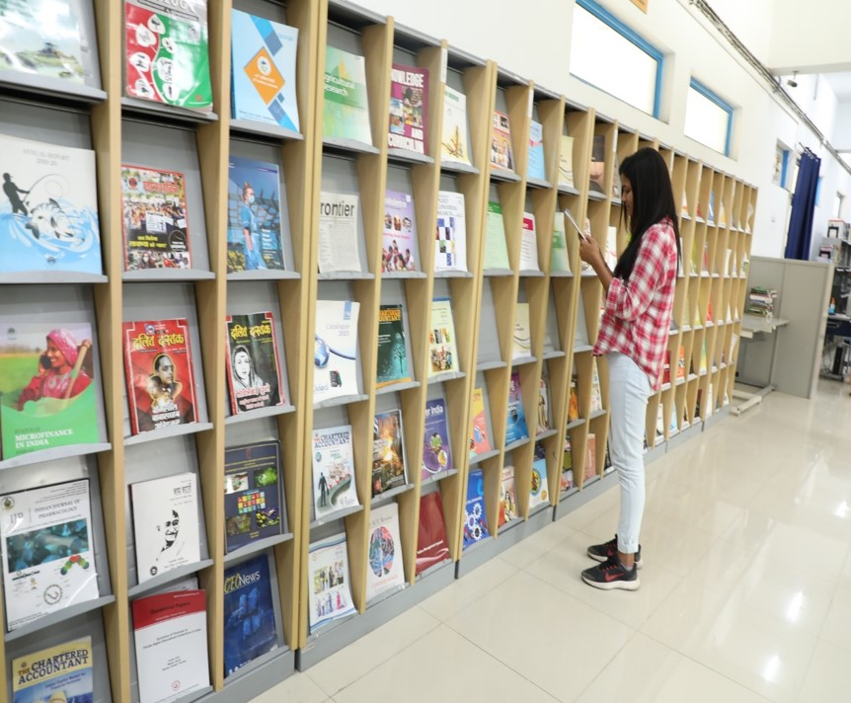

Choosing a University is also about choosing a new home. We ensure that students dwell in a healthy environment that helps them to grow and learn without any obstacle. The University has separate hostels for boys and girls with all modern facilities. The hostel mess serves fresh and hygienic food.
STUDENT HOSTEL

The University has 2 Girls’ hostels and 2 Boys’ hostels. The facilities provided in the hostels are: Wi-Fi, bed, Mattresses, Study Table, Chair, Almirah, 24x7 Water and Electricity supply, Housekeeping facility, Hygienic food, Common Room with TV facility.

Note: Limited hostel facility is available. Hostel to students admitted in P.G. Programmes shall be allotted subject to availability otherwise; they shall have to make their own arrangement for stay.
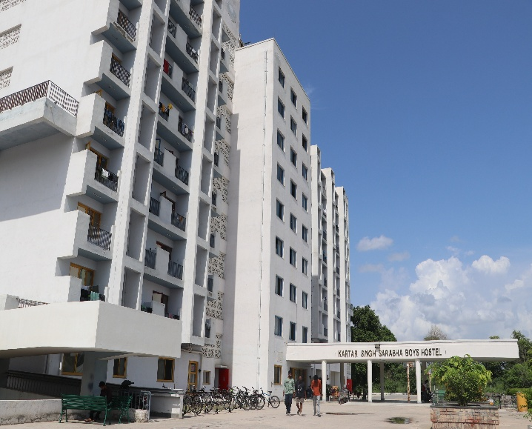
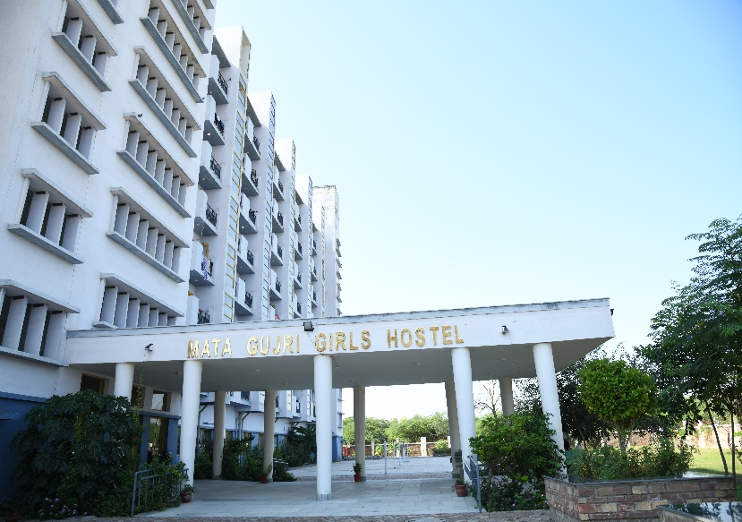

The University greatly values the health of its students and staff. A Health Centre has been established to facilitate treatment of general ailments, first aid and referral services to the employees and students. Two Medical Officers have been appointed on regular basis at the Health Centre. OPD timings are from 09:00 A.M. to 05:00 P.M. except Sunday & Gazetted Holidays. Medicines given from Health Centre are free of cost and emergency kits are provided at various places for First Aid. The Health Centre also looks after the social, preventive and environmental of the Campus.
HEALTH CARE CENTRE

Facilities:
  - Minor OPD facility for treatment of general ailments.
  - In-house facility covering basic medicines and pain killers.
  - In-house availability of Ambulance for referrals by Medical Officer in case of dire emergency on Campus on nominal payment no profit no loss policy.
  - In case of dire emergency, on call availability of Medical Officer and Supporting Staff.
  - Health advisories are issued from time to time.
TRANSPORT
University has buses for convenience of the faculty and students.
MUSEUM
University Museum houses vast collection of archaeological exhibits, including that of Harappan Civilization, excavated from Malwa region of Punjab. Exhibits also include a photo gallery on historical and cultural transformation of Bathinda City.
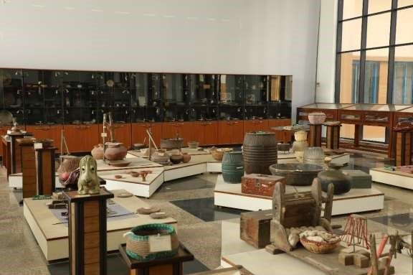

SPORTS
Besides beautiful walking trails around the Campus, the University has good sports facilities for the students and staff. Badminton and table tennis courts are available to foster sporting skills. Outdoor Volleyball, Running track, Football Ground, Cricket Ground and Basketball Courts are available.
“A sound mind lies in a sound body”, therefore, a well equipid air-conditioned Fitness Centre-cum Gym is full functional in the University. Any student can avail benefit of this facility on nominal charges as fixed by the University time to time.

FITNESS CENTRE

The University encourages the students to take up part time jobs at the University to make them independent under the “Earn-While-You-Learn" scheme. The objective of the scheme is to:
EARN-WHILE-YOU-LEARN SCHEME
- Exploit the immense potential of students as a valuable human resource.
- Involve the students in management and development of the Institution.
- Give students hands on experience and thereby prepare them for jobs in future.
- Encourage young students to learn about dignity of labour.
- Prevent students from avoidable distractions and engage them in meaningful, positive activities.
- Enable meritorious and needy students to earn a reasonable amount every month to meet their expenses.
The students who are registered in University for any Programme and are not recipients of fellowship/financial aid from any other funding agency, either private or public can take the advantage of this scheme.
STUDENTS’ FINANCIAL ASSISTANCE FUND
Students Financial Assistance Fund has been created with an objective that no deserving student, as far as possible, is denied opportunity of studying at the University merely due to her/his financial constraints. The deserving students with weak economic background will be eligible for grant subject to the below conditions. However, the amount of grant or loan will depend upon parents’ income and family size etc.:

The performance in the qualifying examination should be up to the mark. The attendance of the student at University should be at least 75% and also academic performance at least “good standing”. She/he should have completed the previous semester successfully. There should be no disciplinary action or proceedings against the student.
*The students can avail of the grant for pursuing studies, payment of tuition fee / payment of registration fee, medical treatment: in case of serious illness demanding hospitalization, attending national international meets, conferences, seminars towards payment of registration fees, 2nd class Train or Bus travel within India or in specific cases even travel abroad (partial assistance) and any other with the approval of the Competent Authority.
(*it is not covered under financial assistance)
EDUCATION LOAN FACILITY
The University makes all efforts to ensure that the financial needs of its students are met. All necessary support needed from the University will be provided to students for applying Education Loan.
PM VIDYA LAKSHMI YOJANA

Education loan is available through PM-Vidyalaxmi Schemes. Please go through the below link for the guidelines regarding Implementation of PM-Vidyalaxmi Schemes in 860 Higher Education Institutions (QHEI issued by the Government of India, Ministry of Education.

Website link: https://pmvidyalaxmi.co.in/Index.aspx

PLACEMENT CELL
The Placement Cell of the University has been established with an aim of facilitating Interactions between the Industries and Students who are in the final year of their Course. The purpose of the Placement Cell is to place students in credible organizations, and help them getting an appropriate job in sync with their intellectual aptitude. To provide excellent facilities for learning combined with a rewarding career is the motto of the Institution. The students are provided with the best research facilities and the lab infrastructure for the execution of their innovative ideas. Helping them to execute it, the dedicated faculty of the University helps them in comprehending the labyrinths of scientific world.
COMMITTEES/CELLS/ASSOCIATION

The students are counselled throughout, during their stay in the University regarding their career options, which in turn prepare and equip the young aspirants to explore the best avenues of opportunities.
STUDENT COUNCELLING CELL
- To counsel and guide students on various issues and help them to manage academic and
personal demands of a University life effectively.
- To help students of all beliefs and identities who may react to certain events with feelings that include anger, hurt, confusion, fear, helplessness, loneliness, and hopelessness.
- To counsel the students requesting a withdrawal from a specific academic Programme for non-academic reasons.
- To provide prompt counselling for mental health emergencies arising on account of highly charged events at the Campus.
- The Student Counselling Cell shall provide comprehensive preventive and clinical services to students enrolled for various academic Programmes in the University. The goal of the Cell would be to enhance the psychological wellbeing of students so they can take full advantage of the educational opportunities at the University. Some of the presentations that the Counselling Center will offer include academic success skill, conflict resolution, dealing with difficult situations, stress management techniques and time management. All student
contacts and information obtained in the course of counselling will be confidential.

GRIEVANCE REDRESSAL CELL
In order to attend to the students' complaints, a Grievance Redressal Cell has been setup in the University. It offers immediate and effective redressal to the problems reported by the students and work towards providing a safe and secure atmosphere for the holisticgrowth of the students. The University has adopted UGC (Redress of Grievances ofStudents) Regulations, 2023. The students may register their grievances as per the notification of the UGC at the appropriate Forum. Central University of Punjab hasalready notified the committees constituted in compliance of the UGC (Redress of Grievances of Students) Regulations, 2023 vide Ref. No. CUPB/COE/2023/138 Dated 08.05.2023. Link is Given Below:https://cup.samarth.ac.in/index.php/site/login OR https://cup.samarth.ac.in/index.php/public_grievance/grievance-public/public

The University has a zero tolerance policy towards ragging-related matters. All issues in this regard will be dealt with utmost urgency and stringent action will be taken against those who are involved. A copy of UGC Regulations on curbing the menace of ragging have been distributed to all students upon admission and have procured undertakings and affidavits from the students as well as parents in this regard. Unabridged version of the UGC Regulations in this regard can be accessible at http://bit.ly/UGC-Ragging.
ANTI-DISCRIMINATION CELL
ANTI-RAGGING CELL
The University community comprises of heterogeneous population from different parts of Country, different religious/caste affiliations, linguistic heterogeneity and persons with various financial backgrounds. Discriminations based on caste/sex/appearance/state of domicile etc. will be dealt with extreme seriousness.

The University puts very best efforts to ensure that the minority community faces no discriminating incidents in the Campus.
COMPETITIVE EXAMINATION CELL
To prepare the students to face different competitive examinations and help them acquire the requisite knowledge to excel in their studies, the University has a Competitive Examination Cell which conducts coaching classes for exams like UGC/CSIR-NET, ICMR, DBT, GATE, GPAT, Civil services examination, etc. Classes for these competitive examinations are held in the evening, so that the regular class schedule of the University is not disturbed.
Coaching is provided in General Knowledge, Information and Communication Technology (ICT), Reasoning (including Mathematical), Current Affairs, Data interpretation, Research Aptitude, People and environment, Higher Education System: Governance, Polity and Administration for UGC NET Paper-I examinations. For CSIR Net examination coaching is provided in Life Sciences, Environmental Sciences, Chemical Sciences and other subjects. Subject specific classes are conducted on the basis of the demand raised by the students. These classes are also in the form of remedial classes. The faculty members also put efforts to provide guidance for the slow learners. A team of committed teachers and specialists of proven merit provide a professional edge to the Cell. Over the years, the Cell has catered to the need of students with fair degree of success. This has greatly helped to improve the performance of all the students in various examinations. The Cell, in the long run, will start coaching for civil services examinations.
Objectives:
- To provide intensive subject specific coaching for UGC/CSIR-NET, ICMR, DBT, GATE, GPAT etc. and Civil services examination (in future);
- To build positive state of mind and self-confidence among the students;
- To encourage SC/ST/OBC and women candidates to appear in competitive examinations.

Dr. Ambedkar Centre of Excellence (DACE) at the Central University of Punjab is established on 1st of April 2022 by Dr. Ambedkar Foundation, Ministry of Social Justice & Empowerment, Government of India. The ministry has approved this centre to coach Scheduled Castes students for Union Public Service Commission’s Civil Services Examination. The aim of the centre is to empower Scheduled Castes students for competitive exams by providing the best and free coaching facilities in the Central University of Punjab. Dr. Ambedkar Centre of Excellence (DACE) at Central University of Punjab aims to contribute to this national scheme through the optimum use of university infrastructure, academic resources, expertise of diverse faculty, and contribution of different cells from the university, and the advantage of location of the university in the state which has the highest percentage of targeted beneficiaries.
DR. AMBEDKAR CENTRE OF EXCELLENCE (DACE)
Personality and Language Development cell of the university has been established to foster soft- skills and communication skills for the students. The cell regularly organizes activities including soft-skill development workshops, communication skills training and general knowledge quiz competition. Students actively participate in these programs in view of today’s highly competitive and stressful academic/career environment. As a part of the activities of this Cell, a Communication Skills and Personality Development training course in English is being conducted three times a week at the Language Lab. The objective of this course is to help students to effectively handle real life communication- specific challenges and to help them grow as leaders. This course aims to enable students to learn techniques of Effective Communication, Personal Interview, Group Discussion, Personality Development and Leadership Skills.
PERSONALITY AND LANGUAGE DEVELOPMENT CELL
SC/ST/OBC AND MINORITIES CELL
SC/ST/OBC and Minorities Cell is committed to provide an environment that promotes diversity and respects everyone regardless of color, religious belief or culture. While maintaining diversity of all kinds, it also commits to ensuring protection of everyone including minorities and acting as per the provisions of Constitution of India.
STUDENT COUNCIL
The students form an integral part of an educational institution. The University also recognizes the students’ potential positively and involves them to nurture their representational skills through the Central University of Punjab Students Council. Both Council and the University jointly work towards the betterment and the advancement of the academic life of the University.
CULTURAL COMMITTEE
The Cultural Committee in the University makes one forget about life’s woes and transports one and all into a world of beats and rhythms. Students are given proper training through experts in dancing, singing, acting, etc. The students perform plays on serious issues like female foeticide, dowry, environment pollution etc. which brings tears to everyone eyes and remind each one present of their duty towards the wrong prevalent in the country. Various events like drama, dance (group and individual performances), skit, musical performances (group and solo), poetry recitation competition, music competition, dance competitions, traditional dress competitions etc. are organized.

The Alumni Association of Central University of Punjab (AACUP) aspires to foster an increased interaction amongst the Alumni. A series of activities will be organized once the Association becomes active. A glimpse of what we as facilitators intend to do are:
ALUMNI ASSOCIATION
- To set up a link with the Alumni of all the Centres/Departments and enroll them as members.
- To encourage the Alumni to take an active and continued interest in the activities and progress of the University.
- To honour those distinguished alumni members, who bring laurels to themselves as well as the University in their respective domains.
- To arrange get-together of the Alumni on a regular basis.
The orientation program is meant to orient the students to the Campus life. The program facilitates the successful academic and personal transition of new students to the University community.
SALIENT FEATURES OF THE UNIVERSITY
DEEKSHARAMBH: STUDENT ORIENTATION

Features
- It gives an overview of University's culture, resources and services along with rules and regulations.
- It is held at the beginning of the Session.

Objectives
- To welcome the student to the University and engage them with the legacy, traditions and values of our University.
- To introduce students to the rigorous academic life of the University and opportunities, responsibilities and facilities available.
- To explain rules and regulations of the University especially related to teaching learning and examination.
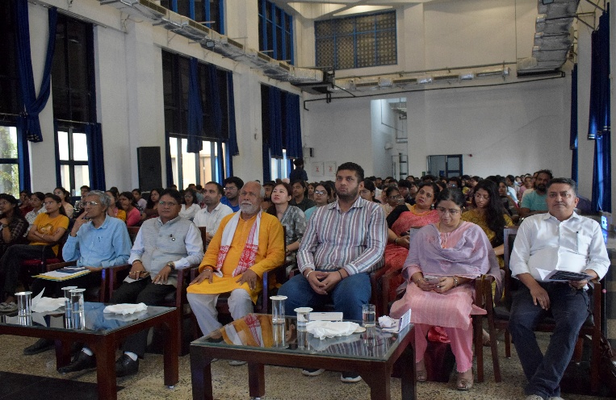
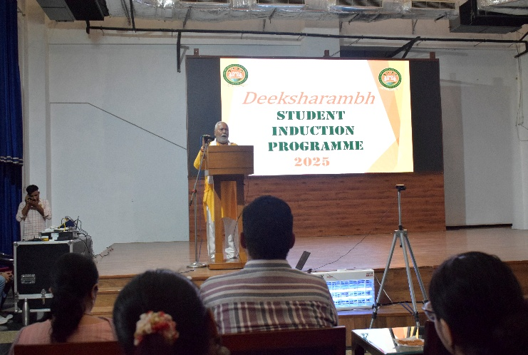

STUDENT CODE OF CONDUCT
The University recognizes and values the diversity of students and their expectations. The University is committed to treating students in a fair and transparent manner. The code of conduct is formulated to provide a clear statement of the University’s expectations of studen ts in respect of academic matters and personal behavior.
  - The student must submit their assignments, Lab. files, seminar reports etc. given by the teachers in time.
  - No student must abstain from classes without prior permission.
  - Students are expected to speak politely and use courteous language when communicating with University officials, staff members and other students.
  - Since all the students to be admitted in the University have attained the age of majority, it is expected that they understand their responsibilities. They are the best judge of their
interests. The students residing in the hostel will be staying in the hostel at their own risk, liability and consequences.
  - Any student participating in sports/training/cultural or any other activity shall take proper care, reasonable intelligence and precautionary measures to avoid any injury. Where any physical injury is caused due to recklessness, violation of rule, laws in existence, safety norms as advised or instructed to undertake such activities, the responsibility shall be exclusively borne by the student. The University shall bear no responsibility for damage caused by the voluntarily acceptance of the risk associated therein. It shall be responsibility of the student to take care in order to avoid injuries. So far as sports are concerned, the purpose of the University is only to facilitate the recreational and rejuvenation opportunities to the students in view of their rigorous academic calendar. Henceforth, the University shall not be liable to any damages, financial or other legal liability for injury sustained by the students in these voluntary activities. The students must buy insurance policy and should avail the benefit of PMJDY (Pradhan Mantri Jan Dhan Yojna) to meet out any exigency or unforeseen mishap.
  - Students must maintain decorum in the University bus.
  - It is the students’ and his guardian’s responsibility to update any changes in their parents / guardians and their own address and contact number within a week. Failure to update may invoke disciplinary action against the student.
  - Wearing a helmet for two wheeler riders is a statutory requirement.
  - Use all University resources including information technology in a lawful and ethical manner for academic purposes only.
  - The students are expected to bear a good moral character.
FEEDBACK SYSTEM
Teaching and learning is a continuous process in which teacher and student develops a bond. Teachers keep getting new students year after year and with the passage of time gain rich experience. In order to improve her/his competence in teaching and/ or research she/he needs the feedback from the students. The students can provide their feedback at the end of every Semester for each Course by hiding their identity. The feedback form is to be filled online, the data of which is kept confidential and is used only for improvement purposes.
RULES & REGULATIONS FOR STUDENTS
- All students are expected to abide by the rules and regulations of the University. Breach of any rule or any other misconduct shall render the student liable for disciplinary action, including expulsion from the University.
- Attendance requirements: All students must attend their classes regularly. The minimum requirement of attendance is 75% of the scheduled lectures.
- Use of Mobile phones: Students possessing mobile phones must keep them switched off when in Class/Labs. Carrying a mobile phone even in switched off mode during examinations is strictly prohibited and shall amount to use of unfair means.
- Ragging: Ragging of any student in any form inside or outside the Campus is punishable offence as per guidelines of Honorable Supreme Court of India with minimum punishment of expulsion from the University. Students and their parents shall be required to submit the undertaking as per Annexure I & II attached with this prospectus.
- Misbehavior: Students found misbehaving with other students or staff member will face disciplinary action.
- Infrastructure Damage: Students must take care of their Campus. Any student found damaging the University infrastructure will be fined to recover the losses.
- Ignorance of the rules and regulations of the University will not be entertained as an excuse.

RULES AND REGULATIONS FOR BOYS’ AND GIRLS’ HOSTEL
BEHAVIOUR AND DISCIPLINE
  - A hostel complex should be a place where students can have the best possible conditions for adequate rest and study. Accordingly, due consideration must be accorded to the interests and privacy of other hostellers at all the times.
  - The students are expected to display acceptable form of behavior, modesty in dress sense in the common dining area representing an institute of national importance, maintain discipline and decorum in the Campus. Being a student of Central Government Institution, the students must present an example of discipline and self-restraint in their conduct.
  - The University equally respects the rights of all and promotes healthy interaction provided no physical affection between the opposite genders is shown at public places which may invoke legal action in case any complaint is filed. Where the students have any grievance, it should be resolved in a peaceful, dignified and amicable manner through the redressal mechanism of the University. In case of any unacceptable behavior by the room-mate, the other room-mate(s) must report it to the Warden/University authorities through Hostel Representatives.
  - The students should not involve themselves or participate in any strike, dharna or protests etc. Any violation of this rule may make them liable under Punjab Prevention of Damage to Public and Private Properties Act, 2014.
  - Possession, distribution and consumption of alcohol beverages, prohibited drugs, and chewable tobacco in the hostel complex is strictly prohibited. Recover of residues of Cigarettes, Tobacco, Alcohol Beverages or any prohibited item shall be punishable with a fine of Rs. 500/- only at the 1st instance. In case of 2nd time, penalty shall be Rs. 1,000/- only. In case of continuance of violation of this rule, the students shall be expelled from the Hostel.
  - All fans, lights and electric appliances must be switched off when not in use. In case, a fan/light or any other electric appliances in a room is in use in the absence of a student or locked room, the 1st time Penalty shall be Rs. 500/- only and in case of 2nd time, penalty shall be Rs. 1000/- only. In case of continuance of violation of this rule, the students shall be expelled from the Hostel.
  - Late night Birthday Parties, Social or Political gatherings or Processions in the hostel complex or within the campus premises are not permitted without the prior written permission of the hostel warden and /or University authorities. Such parties shall be organized only between 8.00 p.m. - 9.30 p.m. with the permission of the appropriate authority. In case of violation or any complaint of physical discomfort or intrusion upon the privacy of other residents in peace hours (9.30 p.m. to 6.00 a.m.) is received, it will be the collective responsibility of the hostel residents involved in any such endeavor and will be proceeded accordingly for disciplinary action.
  - Ragging is a serious offence. The University adopts Zero Tolerance towards Ragging. Hostellers found guilty of committing such an offence can be evicted from the hostel and shall be liable to legal proceedings as per the directives of Supreme Court/MoE/UGC.
  - The students must return to the hostel by 10:00 p.m. every day and are not allowed to leave the hostel before 6:00 a.m.
  - The students will be allowed to stay out of the hostel on submission of proper application duly authorized by the parent on a call received from the designated numbers of parents and only if the permission granted in writing by the hostel warden. Any falsification or impersonation may invoke disciplinary as well as legal proceedings against the guilty.
  - The occupant(s) of a room is/are responsible for any damage to the property in the room during his/her occupancy. In case of damage to or loss of hostel property, the cost + fine equivalent to the amount of cost will be recovered from the student(s) responsible for such damage or loss.
  - The notice Boards of the University shall not be used by the student without written permission of the DSW in case of Academic Block, Dean/HoD in case of Class room and Warden/s in case of Hostels.
  - Competent Authority reserves the right to revise Hostel rules from time to time.
UPKEEP OF THE HOSTEL

  - The student(s) shall not move any furniture from its proper allotted place (room/common room) and not damage it in anyway. No dues to the students shall be given only after verification of the upkeep of room and accessories provided. In case, any of the items issued to the occupant of the room is missing during the occupancy, the occupant shall be responsible for its loss or damage and pay the cost + fine equivalent to the amount of cost.
  - Pasting of posters, writings, wall chalking, slogans of any kind or defacing the hostels or walls of Hostels in any form is not allowed. The resident of the room shall be responsible for upkeep of the room. Where any painting is drawn on the walls or doors of the hostel or any defacing is made by anyone, it will be removed or repainted and the cost shall be recovered from the occupant of the allotted room.
  - The students will be responsible for keeping their rooms’ clean and tidy at all times.
  - Cooking, making tea etc. is not allowed in the hostel. Any extension of plugs or wires is prohibited.
  - Hostel staff, Electricians, plumbers, security and any other service person may enter rooms as and when necessary in the course of their duty under the directive of hostel warden. However, every effort will be made to respect the privacy and dignity of the hostellers.
  - The University Authority reserves the right to make spot checks on the hostel and rooms without having to give prior notice to the students.
  - The University Authority reserves the right to move hostellers to other hostel units or any other alternative place if there is a necessity.
VISITORS
  - Visitors including parents are allowed only into the visitor’s area of the hostel during the visiting hours as follows:-
  - Weekdays (Monday to Friday): 5:00 p.m. to 8:00 p.m. & 7:30 a.m. to 8:30 a.m.
  - Weekend (Saturday & Sunday) and Holidays: 7:30 a.m. to 8:00 p.m.
  - All visitors must register at the Security Section and provide all details and documents as asked before entering the hostel complex. All visitors must leave the hostel complex by 8:00 p.m.
  - Students are not permitted to allow visitors of the opposite sex into rooms at any time for whatever reason. Any hostellers found violating this rules will be evicted from the hostel.
  - Any unauthorized entry in campus premises or hostels shall amount to criminal trespass and will be dealt with according to law in existence.
  - Non-Hostel students are prohibited in the hostel without the permission of hostel warden. The student who violates this is answerable to the Warden.

SECURITY
  - The University Authority is not responsible for any loss of private property. Hostellers are strongly advised to lock all your valuable items such as Mobile phones, Laptop, Watches, Money etc. at all times.
  - Hostellers are not permitted to change rooms or sleep anywhere other in their own room.
  - Any student, who finds anything unusual about his room-mate or finds his missing for more than 24 hours, must report to the hostel Warden immediately. This is to enable the University authorities to take immediate action if any untoward incident takes place.
  - Possession, distribution and use of fire-arms, lethal weapons including air gun, contraband drugs, alcohol, toxic and hazardous material are strictly prohibited in the hostel. Keeping electric appliances such as T.V., VCR, heater, iron, oven etc. in the rooms is also prohibited.
  - Pets are not allowed in the hostel complex.
REVISION OF RULES AND REGULATIONS
The University reserves the right to revise or update the rules and regulations from time to time and will keep the hostellers informed of any changes in the form of notices on the hostel notice boards. Ignorance of rules will not be accepted as an excuse.

IMPORTANT CONTACT NUMBERS
All Important contact number of University Faculty and Employees are available on the University website.

Office | Email address
Dean In-charge Academics | dia@cup.edu.in, daaoffice@cup.edu.in
Registrar’s Office | registraroffice@cup.edu.in
Controller of Examinations' Office | coe@cup.edu.in, controlleroffice@cup.edu.in
Admissions | admissionscup@cup.edu.in
Establishment Branch | establishment@cup.edu.in
Academics Branch | academic.section@cup.edu.in
Dean Students Welfare | dsw@cup.edu.in
Public Information Officer | robin.jindal@cup.edu.in
Finance Branch | fo@cup.edu.in
Computer Centre | sa@cup.edu.in
Library | library@cup.edu.in

LIST OF DOCUMENTS REQUIRED FOR ADMISSION

S.No. | List of Documents | Self-Attested  Photocopy | Original
01. | CUET-2026 Admit Card & Score Card | - | Original#
02. | Secondary School (Class 10th) Marks Sheet Or Valid Certificate of DOB | Self-Attested Photocopy | -
03. | Graduation Marks Sheet or Grade Sheet (As applicable) – First Year | Self-Attested Photocopy | -
04. | Graduation Marks Sheet or Grade Sheet (As applicable) – Second Year | Self-Attested Photocopy | -
05. | Graduation Marks Sheet or Grade Sheet (As applicable) – Third Year | Self-Attested Photocopy | -
06. | Graduation Degree / Post Graduation degree | Self-Attested Photocopy | -
07. | Medical Fitness Certificate | - | Original#
08. | Declaration related to health | - | Original#
09. | Anti-Ragging Form duly signed by the Student & Parents | - | Original#
10. | Certificate of Conduct from Head of Institution/Character Certificate | - | Original#
11. | Migration Certificate - Original* | - | Original#
12. | Category certificate as per GOI rules (Latest  Certificate for OBC candidates - NON CREAMY LAYER etc.) | Self-Attested Photocopy | -
13. | Undertaking for gap year, if applicable. | - | Original#
14. | CSIR-UGC-NET, JRF/GATE/GPAT or any other national level test (with existing validity) recognized by UGC, if applicable. | Self-Attested Photocopy | -
15. | Any other document if needed (… ) | - | Original
16. | Two recent passport size photographs | - | -

Original documents marked # will be retained permanent by the University.
Note: Candidate has to bring all original documents for verification along with one set of self- attested photocopy.

OBC CERTIFICATE FORMAT
FORM OF CERTIFICATE TO BE PRODUCED BY OTHER BACKWARD CLASSES APPLYING FOR APPOINTMENT TO POSTS / ADMISSION TO CENTRAL EDUCATIONAL INSTITUTES (CEIs), UNDER THE GOVERNMENT OF INDIA

“This certificate MUST have been issued with last six months”

This is to certify that Shri/Smt./Kum. _____________________________ Son/Daughter of Shri/Smt. ___________________________________of Village/Town______________________________________ District/Division __________________________ in the _________________________State belongs to the ________________________ Community which is recognized as a backward class under:

- Resolution No. 12011/68/93-BCC(C) dated 10/09/93 published in the Gazette of India Extraordinary Part I Section I No. 186 dated 13/09/93.
- Resolution No. 12011/9/94-BCC dated 19/10/94 published in the Gazette of India Extraordinary Part I Section I No. 163 dated 20/10/94.
- Resolution No. 12011/7/95-BCC dated 24/05/95 published in the Gazette of India Extraordinary Part I Section I No. 88 dated 25/05/95.
- Resolution No. 12011/96/94-BCC dated 9/03/96.
- Resolution No. 12011/44/96-BCC dated 6/12/96 published in the Gazette of India Extraordinary Part I Section I No. 210 dated 11/12/96.
- Resolution No. 12011/13/97-BCC dated 03/12/97.
- Resolution No. 12011/99/94-BCC dated 11/12/97.
- Resolution No. 12011/68/98-BCC dated 27/10/99.
- Resolution No. 12011/88/98-BCC dated 6/12/99 published in the Gazette of India Extraordinary Part I Section I No. 270 dated 06/12/99.
- Resolution No. 12011/36/99-BCC dated 04/04/2000 published in the Gazette of India Extraordinary Part I Section I No. 71 dated 04/04/2000.
- Resolution No. 12011/44/99-BCC dated 21/09/2000 published in the Gazette of India Extraordinary Part I Section I No. 210 dated 21/09/2000.
- Resolution No. 12016/9/2000-BCC dated 06/09/2001.
- Resolution No. 12011/1/2001-BCC dated 19/06/2003.
- Resolution No. 12011/4/2002-BCC dated 13/01/2004.
- Resolution No. 12011/9/2004-BCC dated 16/01/2006 published in the Gazette of India Extraordinary Part I Section I No. 210 dated 16/01/2006.

Shri/Smt./Kum. ________________________ and/ or his family ordinarily reside(s) in the ______________________ District/Division of ________________________ State. This is also to certify that he/she does not belong to the persons/sections (Creamy Layer) mentioned in Column 3 of the Schedule to the Government of India, Department of Personnel & Training O.M. No. 36012/22/93-Estt.(SCT) dated 08/09/93 which is modified vide OM No. 36033/3/2004 Estt.(Res.) dated 09/03/2004.

Dated:
District Magistrate/ Deputy Commissioner, etc.

Seal

NOTE:
- The term ‘Ordinarily’ used here will have the same meaning as in Section 20 of the Representation of the People Act, 1950.
- The authorities competent to issue Caste Certificates are indicated below:
  - District Magistrate / Additional Magistrate / Collector / Deputy Commissioner / Additional Deputy Commissioner / Deputy Collector / First Class Stipendiary Magistrate / Sub-Divisional magistrate / Taluka Magistrate / Executive Magistrate / Extra Assistant Commissioner (not below the rank of Ist Class Stipendiary Magistrate).
  - Chief Presidency Magistrate / Additional Chief Presidency Magistrate / Presidency Magistrate.
  - Revenue Officer not below the rank of Tehsildar and
  - Sub-Divisional Officer of the area where the candidate and / or his family resides.

SC/ST CERTIFICATE FORMAT

FORM OF CERTIFICATE TO BE PRODUCED BY A CANDIDATE BELONGING TO SCHEDULED CASTE OR SCHEDULED TRIBE
This is to certify that Shri/Smt./Kum. __________________________________________ Son/Daughter of Shri ____________________________________________________of village/Town_______________ in District/ Division
of the State/Union Territory belongs to the
Caste/Tribe, which is recognized as a Schedule Caste/ Scheduled Tribe under.

The Constitution (Scheduled Castes) order, 1950. The Constitution (Scheduled Tribes) order, 1950.
The Constitution (Scheduled Castes)(Union Territory) order, 1951. The Constitution (Scheduled Tribes) (Union Territory) order, 1951.
(As amended by the Scheduled Castes and Scheduled Tribes (Modification) Order 1956, the Bombay Reorganization Act, 1960, the Punjab Reorganization Act, 1966, The State of Himachal Pradesh Act, 1970, the North Eastern Areas (Reorganization Act, 1971) and the Scheduled Castes and Scheduled Tribes orders (Amendment) Act, 1976.)
*The constitution (Jammu & Kashmir) Scheduled Caste Order, 1956;
*The Constitution (Andaman and Nicobar Islands) Scheduled Tribes, 1959, as amended by the Scheduled Castes and Scheduled Tribes orders (Amendment) Act. 1976;
*The Constitution (Dadra and Nagar Haveli) Scheduled Castes Order 1962; *The Constitution (Dadra & Nagar Haveli) Scheduled Tribes Order, 1962; *The Constitution (Pondichery) Scheduled Castes Order, 1964;
*The Constitution (Uttar Pradesh) Scheduled Tribes Order, 1967;
*The Constitution (Goa, Daman &Dieu) Scheduled Castes Order, 1968;
*The Constitution (Goa, Daman &Dieu) Scheduled Tribes Order, 1968; *The Constitution (Nagaland) Scheduled Tribes Order, 1970;
*The Constitution (Sikkim) Scheduled Castes Order, 1978;
*The Constitution (Sikkim) Scheduled Tribes Order, 1978;
*The Constitution (Scheduled Castes) Orders (Amendment) Act, 1990.
*The Constitution (Scheduled Tribes) Order, (Amendment) Ordinance, 1991.
*The Constitution (Scheduled Tribes) Order, (Second Amendment) Act, 1991. *The Constitution (Scheduled Tribes) Ordinance, 1996

This certificate is issued on the basis of the Scheduled Castes/ Scheduled Tribes Certificate issue to
Smt. / Shri ______Father of Smt/ Shri _____ of village/town in District/Division of the State/UT who belongs to the caste/Tribe which is recognized as a SC/ST in the State/Union Territory issued by the (name of the prescribed issuing authority) vide their No. Dated or Shri and or his/her family ordinarily reside(s) in Village/Town of District/Division of the State/Union Territory of________________ .

Place | Signature
Date | Designation
 | (With seal of Office)
NOTE: - The terms ordinarily reside(s) used here will have the same meaning as in Section 20 of the Representation of the People Act, 1950. SC Certificate issued from Maharashtra State must be validated by Social Welfare Department and ST Caste certificate must be validated by Tribal Development Department of Maharashtra Government
LIST OF AUTHORITIES EMPOWERED TO ISSUE CASTE/TRIBE CERTIFICATE:
- District Magistrate/Additional District Magistrate/Collector/Deputy Commissioner /Additional Deputy Commissioner/Dy. Collector/ 1st Class Stipendiary Magistrate/Sub Divisional Magistrate/Extra Assistant Commissioner/Taluka Magistrate/Executive Magistrate.
- Chief Presidency Magistrate/Additional Chief Presidency Magistrate/Presidency Magistrate.
- Revenue Officers not below the rank of Tahsildar.
- Sub-Divisional Officers of the area where the candidate and/or his family normally resides.

PWD CERTIFICATE FORMAT

Format for Physically Challenged (PH)/Persons with Disabilities (PWD) Certificate (To be obtained by the candidate)
(To be filled by Medical Board notified under PWD Act)

Affix here recent Photograph showing the disability duly attested by Medical Superintendent
/CMO/Head of Hospital (with seal)

Certificate No:

Date:

This is to certify that Mr./Ms _______________________________________son/ daughter of Mr./Mrs. ___________________ _________________ Age ___ male / female, Registration No. ___________ is a case of . He/She is physically disabled /visual disabled/speech and hearing disabled/ having mental retardation/leprosy cured and has %( per cent) permanent (physical impairment/visual impairment/speech and hearing impairment etc.) in relation to his/her____________________

Note: This condition is progressive/not progressive/likely to improve/not likely to improve*.

1. Re-assessment is not recommended/ is recommended after a period of months / years*. (*Strike out whichever is not applicable)

Signature of Dr. | Signature of Dr. | Signature of Dr.
Name of Dr. | Name of Dr. | Name of Dr.
Specialization | Specialization | Specialization
Seal with Degree | Seal with Degree | Seal with Degree
(Member, Medical Board) | (Member, Medical Board) | (Member, Medical Board)

Signature/Thumb impression of Patient

Countersigned by the Medical Superintendent/CMO/Head of Hospital (with seal)

EWSs CERTIFICATE FORMAT

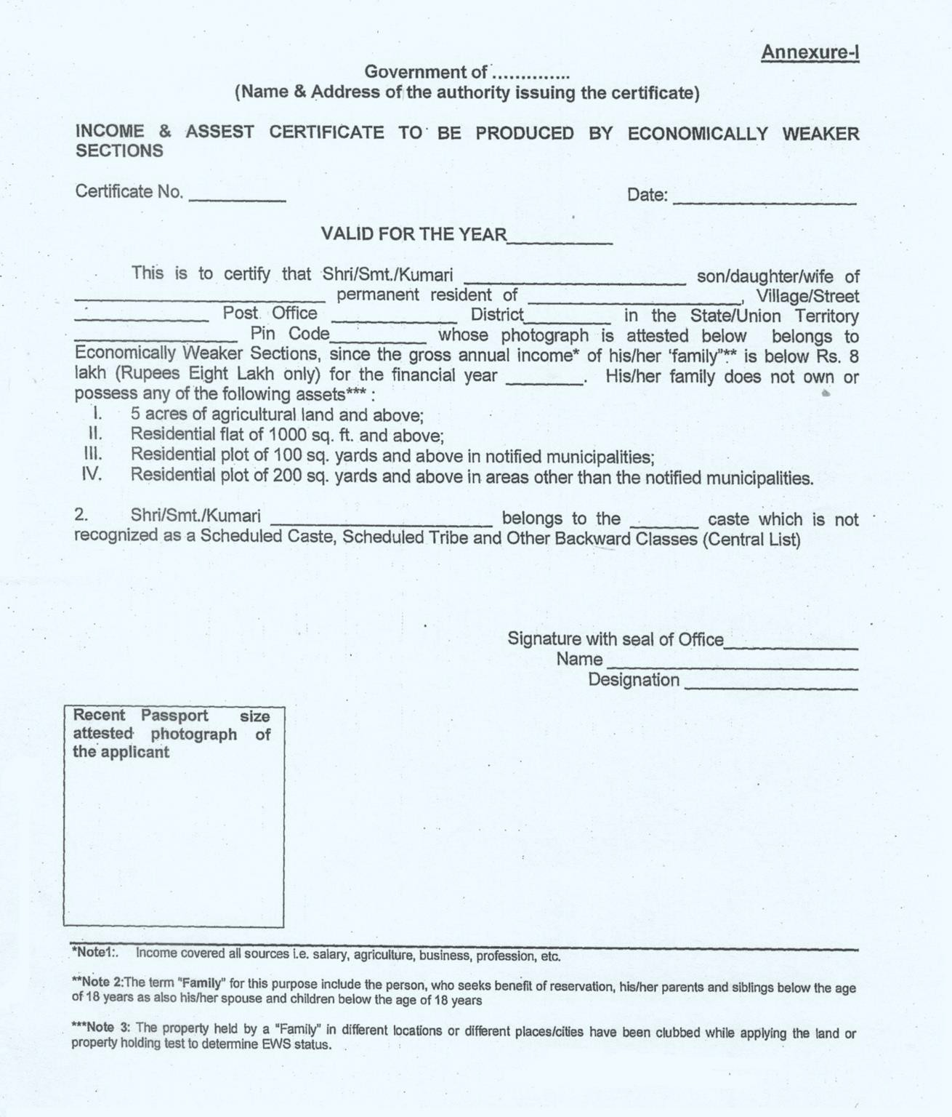

ANNEXURE I
UNDERTAKING BY THE STUDENT

I, (full name of student with Institute Roll Number) s/o d/o Mr./Mrs./ Ms. , having been admitted to (name of the institution) , have received or downloaded a copy of the UGC Regulations on Curbing the Menace of Ragging in Higher Educational Institutions, 2009, (hereinafter called the “Regulations”) carefully read and fully understood the provisions contained in the said Regulations.

- I have, in particular, perused clause 3 of the Regulations and am aware as to what constitutes ragging.

- I have also, in particular, perused clause 7 and clause 9.1 of the Regulations and am fully aware of the penal and administrative action that is liable to be taken against me in case I am found guilty of or abetting ragging, actively or passively, or being part of a conspiracy to promote ragging.

- I hereby solemnly aver and undertake that

  - I will not indulge in any behaviour or act that may be constituted as ragging under clause 3 of the Regulations.

  - I will not participate in or abet or propagate through any act of commission or omission that may be constituted as ragging under clause 3 of the Regulations.

- I hereby affirm that, if found guilty of ragging, I am liable for punishment according to clause 9.1 of the Regulations, without prejudice to any other criminal action that may be taken against me under any penal law or any law for the time being in force.

- I hereby declare that I have not been expelled or debarred from admission in any institution in the country on account of being found guilty of, abetting or being part of a conspiracy to promote, ragging; and further affirm that, in case the declaration is found to be untrue, I am aware that my admission is liable to be cancelled.

- In case, at any stage, if it is found that I do not fulfill the eligibility conditions of admissions at the University my admission will be terminated with immediate effect without any refund.

- Along with the above mentioned points I do hereby declare that

- I will obey the code of conduct of the institute and do not indulge in any kind of in-disciplined activity while in and off the institution campus.

- I will be solely responsible for any kind of accident/mishap caused on account of the above mentioned clause (6.a).
Undertake this day of month of year.

Signature of Student

Name: _________

ANNEXURE II

UNDERTAKING BY PARENT/GUARDIAN

I,Mr./Mrs./Ms. (full name of parent/guardian) father/mother/guardian of , (full name of student with University Roll Number) , having been admitted to (name of the institution) , have received or downloaded a copy of the UGC Regulations on Curbing the Menace of Ragging in Higher Educational Institutions, 2009, (hereinafter called the “Regulations”), carefully read and fully understood the provisions contained in the said Regulations.
- I have, in particular, perused clause 3 of the Regulations and am aware as to what constitutes ragging.

- I have also, in particular, perused clause 7 and clause 9.1 of the Regulations and am fully aware of the penal and administrative action that is liable to be taken against my ward in case he/she is found guilty of or abetting ragging, actively or passively, or being part of a conspiracy to promote ragging.

- I hereby solemnly aver and undertake that

- My ward will not indulge in any behaviour or act that may be constituted as ragging under clause 3 of the Regulations.

- My ward will not participate in or abet or propagate through any act of commission or omission that may be constituted as ragging under clause 3 of the Regulations.

- I hereby affirm that, if found guilty of ragging, my ward is liable for punishment according to clause 9.1 of the Regulations, without prejudice to any other criminal action that may be taken against my ward under any penal law or any law for the time being in force.

- I hereby declare that my ward has not been expelled or debarred from admission in any institution in the country on account of being found guilty of, abetting or being part of a conspiracy to promote, ragging; and further affirm that, in case the declaration is found to be untrue, the admission of my ward is liable to be cancelled.

- Along with the above mentioned points I do hereby declare that

  - My ward will obey the code of conduct of the institute and do not indulge in any kind of in-disciplined activity while in and off the institution campus.

  - My ward will be solely responsible for any kind of accident/mishap caused on account of the above mentioned clause (6.a).

Declared this day of month of year.

Signature of Parent/Guardian

Name:
Address:

Telephone/ Mobile No.:

For Admission Enquiry, please contact Admission Cell at 09464269330
(Monday to Friday 09.00 am to 05:30 pm)

Central University of Punjab

(Established under Central Universities Act, 2009)
VPO: Ghudda, Distt: Bathinda – 151 401 (Punjab), India
Website: www.cup.edu.in
Email: admissionscup@cup.edu.in

